Functional Forms, Market Segmentation and Pricing of Closed-end Country Funds*

Cheng-Few Lee†
Rutgers Business School – Newark and New Brunswick

Dilip K. Patro‡
Rutgers Business School – Newark and New Brunswick

Bo Liu§
Rutgers Business School – Newark and New Brunswick

Alice C. Lee∗
San Francisco State University

This edition: Oct. 2006

Functional Forms, Market Segmentation and Pricing of Closed-end Country Funds

Abstract

This paper proposes a generalized functional form CAPM model for international closed-end country funds performance evaluation. It examines the effect of heterogeneous investment horizons on the portfolio choices in the global market. Empirical evidences suggest that there exist some empirical anomalies that are inconsistent with the traditional CAPM. These inconsistencies arise because the specification of the CAPM ignores the discrepancy between observed and true investment horizons. A comparison between the functional form share returns and NAV returns of closed-end country funds suggests that foreign investors, especially those investors from emerging markets, may have more heterogeneous investment horizons compared to the U.S counterparts. Market segmentation and government regulation does have some effects on the market efficiency. No matter which generalized functional model we use, the empirical evidence indicates that, on average, the risk-adjusted performance of international closed-end fund is negative even before the expenses.

Keyword: Closed-end Country Fund, Functional Transformation, Performance Evaluation

Introduction and Motivation

A nonlinear functional form may arise when returns are measured over an interval different from the “true” homogeneous investment horizon of investors that is assumed by the CAPM (Jensen 1969). Levy (1972) and Levhari and Levy (1977) demonstrated that if the assumption of the holding period is different from “true” horizon, then there will be a systematic bias of the performance measurement index as well as the beta estimate. Lee (1976) has empirically proposed a non-linear model to investigate the impact of investment horizon on the estimate of beta coefficients. Lee, Wei, and Wu (1990) have theoretically derived the relationship between heterogeneous investment horizons and capital asset pricing model. Fabozzi, Francis, and Lee (1980) have used a generalized functional form approach developed by Zarembka (1968) to investigate the open-ended mutual fund return generation process. Chaudhury and Lee (1997) use the functional form model for international stock markets to investigate whether the international stock markets are integrated or segmented.

The U.S. traded international closed-end funds provide a useful testing gear for the market efficiency in the framework of functional transformation. Mutual funds provide investors with heterogeneous investment horizons a vehicle in investment. As mentioned in Johnson (2004), investors’ liquidity needs are primarily revealed by their investment horizons. His empirical result shows that investors’ liquidity needs can vary significantly across individual investors, which leads to an obvious heterogeneous investment horizons phenomenon according to his duration model. The closed-end funds are unique in that they provide contemporaneous and observable market-based rates of returns for both funds and underlying asset portfolios. Moreover, for most funds the value of the underlying portfolio is known with considerable accuracy since the component assets are listed on the stock market. However, close-end funds typically trade at a substantial discount to the underlying value of their holdings (the net asset value (NAV) of the fund). The discount value is not constant, and varies considerably over time. Unlike domestic closed-end funds, international closed-end funds shares and underlying assets are traded in different markets. Therefore, share returns and NAV returns may display totally different distribution characteristics according to the corresponding markets. Investors from different markets will also have different consumption patterns and investment horizons, especially those investors from emerging markets. Prior research of Chang et al. (1995) finds that except for the Mexico Fund, the shares of a sample of 15 closed-end country funds did not outperform the Morgan Stanley Capital International (MSCI) world market index for the 1989-1990 period. Patro (2001) also provides evidence of inferior performance of risk-adjusted share returns and NAV returns of 45 US based international closed-end funds over the 1991-1997 period.

The main purpose of this paper is to propose a generalized functional form model for closed-end mutual fund performance evaluation. Firstly, we want to investigate whether the negative performance of international closed-end funds documented by previous studies is due to an incorrect specification of the return generating process. Secondly, we want to test whether international closed-end funds investors have heterogeneous investment horizons. Thirdly, we want to provide a comprehensive analysis of the relationship between the functional form of the returns and fund characteristics, with special attention given to the difference between emerging funds and developed funds, single country funds and regional funds.
We also consider the short sale effect on the generating process of international CEFs returns. Short sale plays an important role in the determinant of the market efficiency. On the one hand, short sale facilitates efficiency of the price discovery; on the other hand, short sale may also facilitate severe price declines in individual security. A common conjecture by regulators is that short-sales restriction can reduce the severity of price declines. Hong and Stein (2002) developed a model linking short sale constraints to market crashes, where they find investors with negative information cannot reveal their information until the market begins to drop if they are constrained from short selling. And their activities will further aggravate market declines and leads to a crash. Most research suggests that short sale constraints have an adverse effect on the market efficiency. Empirical evidence from both the U.S. and non-U.S. markets also supports the theoretical view that constraining short sale hinders price discovery – particularly when the news is bad. Aitken et al. (1998) provides evidence that short sale trades reflect significant bad news about companies. Jones and Lamont (2002) shows that stocks with expensive short sale cost have higher valuation and thus lower subsequent returns, which is consistent with their hypothesis that stocks that are difficult to short sale are overpriced. Bris, Goetzmann, and Zhu (2004) finds that there exists significant cross-sectional variation in equity returns in the markets where short selling is allowed or practiced controlling for a host of other factors, while no such evidence displayed in the non-short-selling markets. Although we doubt closed-end country fund managers will undertake short sale in their portfolio investment, short sale does affect investors’ behaviors in the local markets, which will further affect the prices of the stocks in the local market. Taking a look at the data generating process of international CEFs, especially the movement of NAV returns, will bring us a clear feeling about the effect of government regulations on the financial markets.
In this paper, we use the generalized functional form approach to investigate 90 closed-end country funds. Both linear and loglinear assumption of the return generating process have been rejected for nearly 25% of closed-end country funds. The wide distribution of estimated transformation parameters indicates that investors from foreign countries (especially emerging countries) have more heterogeneous investment horizons compared to the U.S. counterparts. The government regulation (short sale) effect on the functional form only exists on the NAV returns. We found that most of the international closed-end country funds are not integrated with the world market, even though the global risk has been priced in several models. Consistent with previous research, after the consideration of the functional form transformation of share returns, international closed-end country funds generate negative risk-adjusted returns, no matter which benchmark we use. Moreover, in the framework of generalized CAPM, consistent with previous research, all factors in Carhart (1997) four-factor model remain as important pricing factors. However, when we include the global return into the model, the momentum factor no longer plays an important role.
This paper is organized as follows. In section II, we investigate the appropriateness of the functional form used by previous research. In section III, a generalized international capital asset pricing model is used to test whether the closed-end fund is integrated with the world market or not. Section IV describes the data and testing methodology used in the empirical analysis. Finally, the empirical results are summarized in section V and the conclusion is given in section VI.

Literature Review

CES functional form of the CAPM
The traditional CAPM assumes that all investors have the same single-period investment horizon. However, this assumption is unlikely to be true. In reality individual investors have multiple investment horizons depending on their consumption patterns. The explicit consideration of multi-period investment horizons generates several important implications on the empirical estimation of the systematic risk and the risk-return relationship. One of the multi-period investment analyses is the nonlinear functional form of CAPM.
Tobin (1965) pioneered the study of multi-period investment CAPM. He analyzed the effect of the heterogeneous investment horizon on portfolio choices and developed a relationship between the risk and return measures of the single-period investment horizon and those of the multi-period investment horizon. Following Tobin’s work, Jensen (1969) was the first to investigate the effect of investment horizon on the estimation of the systematic risk. Based on the instantaneous systematic risk concept, he concluded that the logarithmic linear form of the CAPM could be used to eliminate systematic risk. However, Jensen did not include the investment horizon parameter in his model.
Lee (1976) extended Jensen (1969)’s work and derived the CES functional form of the CAPM that introduces the functional form investment parameter into regression directly and then estimates the systematic risk beta in a homogeneous investment horizon framework. Lee (1976) showed that based on a homogeneous mean-variance preference structure and an equilibrium market, a risk-return relationship can be defined as:
(1)
Where H is the investment horizon assumed by the CAPM
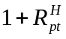 is the holding period return on the p^{th} portfolio,
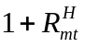 is the holding period return of the market portfolio
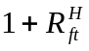 is the holding period return of the risk-free asset
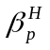is the systematic risk
Equation (1) implies that the risk return tradeoff is linear only when the investment horizon is same as it assumes by the CAPM. If the observed horizon is defined by N, which is not the same as H, then (1) can be rewritten as:
(2)
where 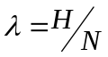,
In order to get the full nonlinear estimation in the above equation, using logarithm and Euler expansion, equation (2) can be rewritten as:
(3)
where 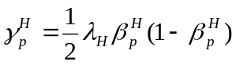
This implies that the CAPM should include a quadratic excess market return if 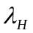is not trivial. Following the standard regression method, both and 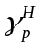can be estimated. The adjusted coefficient of determination will reflect whether the new parameter of can improve the explanatory power of the CAPM. If the quadratic market return is significantly different from zero and is arbitrarily omitted, then the estimated systematic risk may be subjected to the specification bias.

Generalized functional form of the CAPM
Using the Box-Cox (1964) transformation technique, Lee (1976) and Fabozzi, Francis and Lee (1980) developed a generalized model to describe the mutual fund return-generating process:
(4)
where 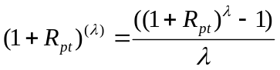, 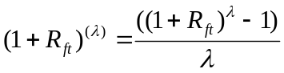,
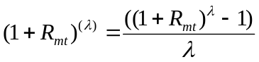, 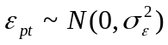
is the functional transformation parameter to be estimated across the p^{th} mutual fund’s time series rates of return.
Equation (4) includes both the linear and log-linear functional forms as special cases:
When =1, 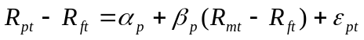
When =0,
Box and Cox (1964) used the maximum likelihood method to determine the functional form parameters.
(5) 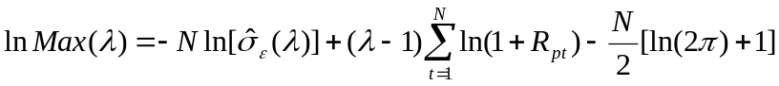
Where N is the number of observation and 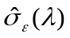is the estimated regression residual standard error of equation (4). After equation (4) is estimated over a range of values for , equation (5) is used to determine the optimum value for that maximizes the logarithmic likelihood over the parameter space.
McDonald (1983) found a generalized model to be appropriate in a significant number of cases of his sample of 1164 securities, although the bias of the CAPM beta did not appear to be material. Generalized functional form has also been found in the international stock market. Chaudhury and Lee (1997) found that the linear (loglinear) empirical return model could be rejected for more than half of the international sample of 425 stocks from 10 countries.

Translog functional form of the CAPM
Jensen (1969), Lee (1967), Levhari and Levy (1977), and McDonald (1983) investigated the empirical implications of multi-period investment, but none of them has provided a generalized asset pricing model for the equilibrium risk-return relationship under heterogeneous investment horizons. In order to control the systematic skewness from the square-term of a market excess return in the CES functional form of the CAPM, Lee, Wu and Wei (1990) proposed the translog functional form of the CAPM in a heterogeneous investment horizon framework:
(6)
Where 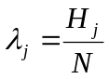,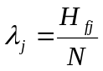,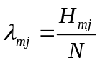and  and are investors’ weighted time horizon and observed time horizon respectively. Note each portfolio has different set of . When 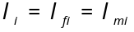, it reduces to homogeneous generalized functional form CAPM.
The translog function form provides a generalized functional form that is local second-order approximation to any nonlinear relationship. For many production and investment frontiers employed in econometric studies, the translog function often provides accurate global approximations. Moreover, the translog model permits greater substitution among variables. Thus, it provides a flexible functional form for risk estimation. Finally, this model can be estimated and tested by relatively straightforward regression methods with a heterogeneous investment horizon.
All of the three alternative functional CAPM models can reduce the misspecification bias in the estimates of the systematic risk and improve the explanatory power of the CAPM.

Model Estimation

Generalized functional form model for closed-end fund
Using the technique of Box-Cox (1964), Lee (1976) and Fabozzi, Francis and Lee (1980) developed a generalized model to describe the mutual fund return-generating process. Following their approach, we define the generalized Box-Cox functional form of the international closed-end fund return as follows:

(7)
where 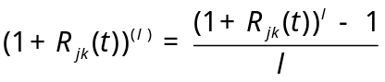 , 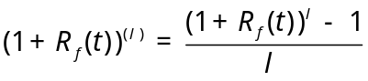,
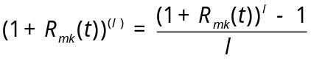, 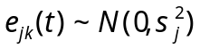
is the functional form parameter to be estimated across the mutual funds.
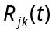 is the monthly rate of return (shares and NAV) for the closed-end fund j which invest in country k in period t
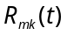is the monthly market rate of return of country k in period t
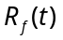 is risk free rate of interest in period t
Equation (7) can be rewritten as:
(8)
Equation (8) is a constrained or restricted regression. Equation (7) includes both linear and log-linear functional forms as special cases:
when 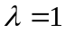, it reduces to the linear case:
when approach zero, it reduces to the log-linear case:
Following Box and Cox (1964), we use the maximum likelihood method to determine the functional form parameter:
where N is the number of observation and 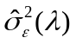is the estimated regression residual standard error and
Given the unrestricted estimates of parameters 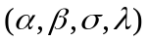, a model that is linear () or log-linear (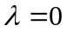) is a simple parametric restriction and can be tested with a likelihood ratio statistic. The test statistics is
.
This statistics has a chi-squared distribution with one degree of freedom and can be referred to the standard table (5% critical value=3.84). We can use the difference of these two likelihood values to test whether of each fund is significantly different from zero or one.

Functional form of the International Closed-end Country Fund Model
In the context of international asset pricing, if the world capital market is integrated, ex ante risk premium on a security equals ex ante risk premium of global market portfolio times the security’s systematic risk with respect to the global portfolio (Solnik, 1974). However, Solnik (1974b,c) and Lessard (1974) also report that there are strong national factors that present in the price generating process of individual securities. Hence Solnik (1974) suggested using a two-factor model for individual securities.
A direct extension to Solnik’s model would lead us to the generalized functional form of the international capital asset pricing model for closed-end funds:

(9)
where ,,
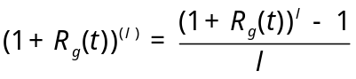, 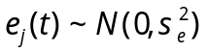
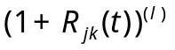 and 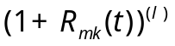are generalized transformation of the monthly CEF return (both share returns and NAV returns) and the monthly market return of country k. 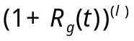 is the transformed monthly return on the global market portfolio. Both 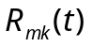and 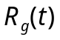 are commonly proxied by the return on the country stock index and the global stock index.
In an integrated world market, the pure national risk 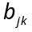 would not be priced since it can be diversified away through international investments. On the other hand, in an extreme segmented market, the international risk 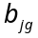 would not be priced (Errunza and Losq (1985), Jorion and Schwartz (1986)). In a mildly segmented market (Errunza and Losq (1989)), the pure national risk of securities in which foreign investment is not allowed would be priced as in the case of complete segmentation, but their global systematic risk would also be priced as in the case of complete integration. In addition to the two-factor generalized global CAPM model, we also consider the generalized single factor model with only global index as the pricing factor. Pioneering work by Carhart (1997) has shown that the four-factor model, which includes a momentum factor, is superior to both the CAPM and the Fama-French three-factor model in explaining the cross-sectional variation in fund returns. We further extend our generalized CAPM model into the framework of Carhart four-factor model.
In this paper, we focus on the empirical specification of return generating process in the context of international asset pricing. We would explore whether it is worthwhile to include a global index in the generalized two-factor model. Specifically we will compare the generalized functional form of CEF between developed markets and emerging markets, between single country funds and regional funds, and between short sale allowed country funds and short sale not allowed country funds.

Data and Methodology

Data
The total sample of data includes 90 U.S. traded international closed-end country funds with complete monthly data (last Friday) from July 1965 to Dec. 2003. These returns are adjusted for capital distribution, stock splits, dividends and right offerings. All of the data are in the US dollars. Table 1 lists the fund name, fund code, IPO date and the total number of observations. The market indices of different countries and regions are also included in Table 1.
Our sample data include 55 single country closed-end funds and 35 regional closed-end funds, with their underlying assets traded in 31 different countries. We divide those funds into two groups: developed market funds and emerging market funds, according to the country of their underlying asset. Among these funds 19 funds invest in developed markets, 53 funds invest in emerging markets, while the other 18 funds invest in both.
We also classify each fund according to the regulation policy of short sale in the invested countries. Among these countries, the first group includes most developed markets such as U.K., Australia, Austria, Belgium, Canada, Czech Republic, Denmark, France, Germany, Ireland, Italy, Japan, Mexico, Netherlands, Portugal, South Africa, and Switzerland where short sale is allowed and practiced; the second group includes the countries where short sale is not allowed or not practiced, they are Colombia, Greece, Indonesia, Pakistan, Singapore, South Korea, Taiwan, Argentina, Brazil, Chile, Finland, India, Israel, New Zealand, Philippines, China and Spain; and the last group includes three countries (regions) that short sale regulation and practice changed during our sample period, they are Hong Kong, Malaysia and Thailand. Altogether there are 35 funds that invest in countries or regions where short sale is allowed or practiced, and other 46 funds that invest in countries or regions where short sale is not allowed or practiced.
The market indices for different countries, regions and the world market used in this study are from MSCI of Morgan Stanley. The U.S. market index used is the monthly return of the CRSP value weighted composite index. The problem of assuming a riskless rate in an international context is well-known, and it is especially troublesome for international capital market where a domestic market determined short-term rate similar to the U.S. T-bills is generally not available. Since we have no domestic market short rate information, instead we use 30-day U.S. T-bill rate as a proxy. All information of the Fama-French three factors and the momentum factor is downloaded from Kenneth French’s website.
Table 2 reports the descriptive statistics for the share returns and the NAV returns of international closed-end funds. The price return and the NAV return are calculated as follows:
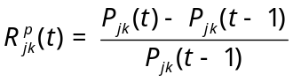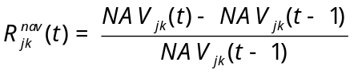
Where 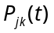and 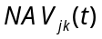 are share price and NAV for fund j investing in country k during period t. The average monthly share return is 0.73%, which is higher than 0.53% of the average monthly NAV return. However, the average standard deviation of the share return is only 9.93% compared to 10.7% of the average standard deviation of the NAV return. This partly reflects the higher risk of the underlying foreign countries’ assets of CEFs, especially of those emerging markets.

Methodology
To determine the appropriate functional form of the CEF, for the share return, we use both local country index and the U.S. CRSP value weighted composite index return as the proxy of the market return; for the NAV return, we only use the monthly return of the local country index as the proxy of the market return. The use of respective local market indices as benchmarks may be motivated by noting that the funds are constrained to invest most of their assets in equity securities of one country or region, and if the fund managers are market timers, they are more likely to time the respective local market. Therefore, it is of interest how the funds compare to the passive market portfolios. Since all of these funds are traded in the U.S. market, and their price movements are also affected by the U.S. market, therefore, using the CRSP value weighted composite index as the benchmark for the share return is reasonable.
The generalized functional models used for the share return and the NAV return of international closed-end funds are as follows:

- Share return
GCAPM Model:
GCAPM-CRSP Model:
Global Index Model: 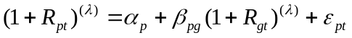
Global GCAPM Model:
Global GCAPM-CRSP Model:
Global Carhart GCAPM Model:

- NAV return
GCAPM Model:
Global Index Model: 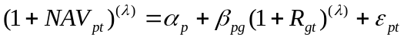
Global GCAPM Model:

where 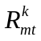 is the monthly return of country k’s index, 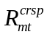 is the monthly return of the CRSP value weighted composite index, 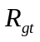 is the monthly return of the MSCI global market index. Altogether, we use six different generalized models for share returns and three different generalized models for NAV returns.
The objective of this paper is to determine whether the global index needs to be included in the empirical return model in addition to the national or domestic market index. MLE estimation of generalized functional model provides the alternative pairs of coefficient estimates and t-ratios. We wish to see whether the coefficient of the global index is significant, and more importantly, the choice of functional form matters with respect to the significance of the global index.
Additionally, the underlying assets and closed-end funds are traded at different markets, investors from different markets may have different investment horizons. Even for the same closed-end fund the functional form model of the share returns and the NAV returns may be different. Therefore, we want to investigate the difference of the functional form model between share returns and NAV returns of closed-end funds, as well as the difference between emerging market funds and developed market funds, between single country funds and regional funds.
To test whether funds’ characteristics will affect the functional form specification, we use two approaches for the comparison. Firstly, we run the grouped regression that pools across all CEFs based on different grouping criterions. We divide all of CEFs into six groups: single country funds vs. regional funds, emerging market funds vs. developed market funds, short sale allowed funds vs. short sale not allowed funds. Secondly, we pool all data into one group across time and funds. In addition, we add different fund characteristics as dummy variables in the estimation. Pooling data across funds and time allows us to test the determinants of the cross-sectional variation in the functional transformation. Several specifications of the pooled model are estimated. In order to control the heteroskedasticity problem, we use White t-statistics that is based on the standard error robust to heteroskedasticity.
For all of our empirical tests with pooling data for international CEFs share returns and NAV returns we use the different specification of the following model respectively:

where 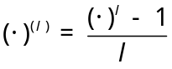 and 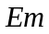,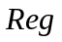,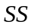 are dummy variables of funds’ characteristics for emerging markets funds or developed market funds, regional funds or single country funds, short sale allowed country funds or not allowed country funds.

In general, we summarize the test hypothesis of our empirical study as follows:

Test 1: The coefficients of the global index return as well as the national market index return are significant. → to test the market segmentation.
Test 2: The functional form of CEF does matter (functional transformation parameter lambda is significant) in the context of global asset pricing model. → to test the heterogeneous investment horizons.
Test 3: There exists significant difference of the functional form between share returns and NAV returns of international closed-end funds. → to test the difference of investors’ behavior from the U.S. market and foreign markets.
Test 4: There exists significant difference of the functional form between closed-end funds investing in emerging markets and developed markets. → to test the market maturity’s effect on the functional form.
Test 5: There exists significant difference of the functional form between single country closed-end funds and regional closed-end funds. → to test whether there exists cross-market effect.
Test 6: There exists significant difference of the functional form between international CEFs investing in short sale allowed countries and those investing in short sale not allowed countries. → to test the government regulation’s effect on the market efficiency.

Empirical Results

Generalized functional form for international closed-end fund
Unlike McDonald (1983) and Chaudhury and Lee (1997), we find the transformation parameter to be positive on average. In table 5, we find the average of all share returns in GCAPM is 0.218, which is smaller than the average of NAV returns, and this similar pattern remains no matter which model we use. The absolute magnitude of seems a little higher for NAV returns compared to the share returns. Another noticeable feature is the dispersion of across the funds in our sample. The standard deviation of changes from 1.248 to 2.717, and the minimum and maximum value of range from –11 to 13. These dispersion measures are rather large relative to the mean and median values. This indicates the fund-specific nature of the transformation parameter and raise question about the conventional use of the same transformation parameter (usually 1 for linear and 0 for loglinear specification) for all securities. Moreover, from figure 1 we find the distribution of of the NAV returns is more disperse compared to that of the share returns, and there exists some skewness in most of the distributions of . The large dispersion of for NAV return indicates that foreign investors have more heterogeneous investment horizons compared to the U.S. investors.
In table 3 we report the rejection rate of the hypothesis of linear and loglinear return. Irrespective of which generalized model we use, the loglinear return hypothesis is rejected for at least 30% of our sample funds, and the linear return hypothesis is rejected for more than 45% of the funds. These numbers increase to 58.4% and 55% of the NAV returns for global GCAPM model. The GCAPM model of the share return has the lowest rejection rate, where neither linear nor loglinear hypothesis can be rejected for 60% of funds. When we substitute the market return with the CRSP value weighted index return, more funds are rejected for the linear or loglinear hypothesis (rejection rate for both hypothesis increases to 20%). This reflects that the heterogeneous investment horizons for U.S. investors are more significant when we treat international closed-end fund in a local environment rather than in the global environment. However, when we include global market return in the model specification, the rejection rates also increase. This implies that in order to explore the heterogeneous investment horizon in the context of international asset pricing, the global market return should be included. In the next section we also test whether the global risk is priced in the framework of functional form CAPM. From table 3 we also find an obvious pattern that, on average, the rejection rate of the NAV returns is higher than the rejection rate of the share returns for the corresponding model. This is reasonable since compared to the U.S. market (where share funds traded), the foreign countries’ investor (where the NAV of funds is determined) have more heterogeneous investment horizons. The linear or loglinear specification of security return may be more inappropriate for international financial markets, especially for those emerging markets. We will explore the difference between developed markets and emerging markets further in the following section.
When we compare the intercept of the generalized models, the average excess return (alpha) after controlling for the market risk premium is only -0.11% for the share returns and –0.33% for the NAV returns, while the average excess return of the share returns for the conventional linear model is 0.05% and -0.13% for the loglinear model, and the corresponding number of the NAV return is –0.14% and –0.44% respectively. This interesting result indicates that the functional form of returns does affect the performance evaluation. Consistent with Patro (2001), the NAV return seems to perform slightly worse compared to the shares when performance is measured using the local market portfolios.

Generalized global model for international closed-end fund
Using a local market index to evaluate performance is appropriate only in fully segmented international capital markets. Therefore, using a benchmark that is likely to be mean-variance efficient in a global pricing context is important. Although the evidence in favor of the domestic CAPM is ambiguous, several authors such as Cumby and Glen (1990), Harvey (1991), Ferson and Harvey (1994) and Chang et al. (1995) provide evidences in favor of the mean-variance efficiency of the MSCI world market index. When we include the global index in the pricing model, we find the rejection rate of the conventional linear or the loglinear model is higher compared to the model with only local market index.
Consistent with previous research, the global market risk has been priced in most of the international closed-end funds. We find that the coefficient of global return is significant for all of developed country funds and most of emerging country funds, no matter we use share returns or NAV returns. This may partly provide evidence that all developed market and most emerging markets are integrated markets, at least mildly segmented markets. When we compare the one-factor generalized global index model and the two-factor generalized global model, we find an interesting feature. After we introduce the local market return into the global index model, risk premium 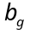of the global factor reduces and the risk premium of the one-factor generalized global index model is nearly equal to the summation of the risk premium of the local market return and the global return in the two-factor generalized global model.

Comparison of functional form model between developed market funds and emerging market funds, between regional funds and single country funds, between short sale allowed country funds and short sale not allowed country funds
As our expectation, there exist significant different patterns of transformation parameters between emerging market funds and developed market funds no matter which model we use. From Panel A of Table 6, we find developed markets generally have negative transformation parameters while emerging markets have positive transformation parameters. The only exception is the GCAPM model for the share return, where is positive and insignificantly different from 0. This implies that the conventional loglinear return can be used in the pricing model of share returns for the developed markets. However, this is not true for the emerging markets, which have a significant positive and the factor loading of the market return is also smaller than that of the developed markets. Results of the NAV return from Table 7 tell us another story. The transformation parameters of the developed market funds change to positive while the emerging market funds do not have consistent . The significant different patterns of transformation parameters also exist between single country funds and regional funds. All single country funds’ share returns produce significant negative while regional funds’ share returns have significant positive . Although the NAV return does not have this obvious positive-negative pattern, the value of is really smaller for the single country funds compared to the regional funds. A comparison between short sale allowed country funds and short sale not allowed country funds also gives us a similar pattern with regional funds. Short sale allowed country funds have consistent positive for both share returns and NAV returns.
Results from the pooled regression, as reported in Table 6 and Table 7, are also supportive of a significant global risk premium. No matter which model we use for both share returns and NAV returns, the factor loadings of the global risk is significant positive for both developed market funds and emerging market funds, regional funds or single country funds, short sale allowed funds or short sale not allowed funds. Moreover, in the framework of the generalized CAPM, consistent with previous research, all factors in Carhart (1997) four-factor model remain significant, including the size factor after controlling for the momentum factor. And the factor loadings of each model are consistent with our expectation. However, when we include the global return or the local market return into the model, the momentum factor no longer plays an important role.
As reported in Table 8 and Table 9, results of cross-sectional pooling regression give us another view to compare the differences among different model specifications for the functional form of international CEFs. Firstly, all of the transformation parameters are significantly positive, with larger for share returns than for NAV returns. Consistent with the grouped regression, the global risk has been priced in each of generalized model, even controlling for the local market returns. Although the transformation parameters are significant for each model, the factor loadings between the generalized model and the linear or the loglinear model are similar, especially for the NAV returns. The results from generalized model are more close to the models with loglinear returns, which implies that the conventional use of loglinear return is still reasonable. Controlling for the risk factors in the generalized model, the dummy variables do not produce significant result for share returns. However, the dummy variables of and are significant for NAV returns. This implies that the difference between the emerging market and the developed market, and the difference between short sale allowed country funds and short sale not allowed country funds are more significant for NAV returns. This is consistent with the characteristics of international closed-end funds, underlying assets are traded in foreign markets while share returns are determined by the U.S. investors. Hence NAV returns should reflect the difference among different funds more significantly.

Performance evaluation
Motivated from Jensen (1969), Lee (1976) among others, one of the important applications of the generalized CAPM is to give a more unbiased and efficient performance evaluation for mutual funds. In Table 10 we report the risk-adjusted returns of each model for share returns and NAV returns of individual fund. Consistent with previous research such as Patro (2001), the average performance of international CEFs is negative, even before the exclusion of fund expenses, no matter we use the generalized model, the linear model or the loglinear model. The grouped regression and cross-sectional pooling regression give us similar results.

Conclusion
In this paper, we investigate the functional form specification of 90 U.S. based international closed-end country funds. With regards to the functional form, our results suggest that the frequently used linear and loglinear specifications of security return may be inappropriate for many funds. The use of a generalized functional form should be the rule rather than an exception. The evidence against the linear functional form in our sample indicates that the investment horizon is likely different from one month. For most funds, the true investment horizon is not instantaneous either.
Similar to MacDonald (1983) and Bubnys and Lee (1989), we encounter many negative estimates for the horizon parameter in our sample. Lee and Wei (1988) have shown that the estimated will be negative instead of positive if the security return and the market return had a bivariate lognormal distribution. Similar for most funds, some of the NAV returns seems to perform slightly worse compared to the share returns.
Our empirical results imply that the functional transformation does matter for international CEFs. The global risk has been priced in the framework of generalized CAPM. The momentum factor is no longer an important factor in asset pricing of share return of international CEFs after controlling for the risk factor of the global market return and the local market return. No matter which benchmark we use, international CEFs make negative risk adjusted performance. Moreover, there exit significant different patters of functional form between emerging market funds and developed market funds, single country funds and regional funds, short sale allowed country funds and short sale not allowed funds. A comparison between the functional form share returns and NAV returns of closed-end country funds suggests that foreign investors, especially those investors from emerging markets, may have more heterogeneous investment horizons compared to the U.S counterparts.

Reference
Aitken, Michael, Frino Alex, Michael S. McCorry, and Peter L. Swan, 1998, “Short Sales are Almost Instantaneously Bad News: Evidence from the Australian Stock Exchange”, Journal of Finance, 53, 2205-2223

Bekaert, G., and M. Urias, 1996, “Diversification, Integration and Emerging Market Closed-end Funds,” Journal of Finance, 51, 835-869

Box, G.E.P, and D.R.Cox, 1964, “An Analysis of Transformation,” Journal of the Royal Statistical Society, Series B, 211-243

Bris, Arturo, William N. Goetzmann, and Ning Zhu, 2004, “Efficiency and the Bear: Short Sales and Markets around the World”, working paper, Yale School of Management

Bubnys, E.L., and C.F.Lee, 1989, “Linear and Generalized Functional Form Market Models for Electric Utility Firms,” Journal of Economics and Business, Vol. 41, 213-223

Carhart, Mark, 1997, “On Persistence in Mutual Fund Performance”, Journal of Finance, 52, 57-82

Cartwright, Phillip A. and C.F.Lee, 1987, “Time Aggregation and the Estimation of the Market Model: Empirical Evidence,” Journal of Business and Economic Statistics, Vol. 5, 131-143

Chang, E., C. Eun, and R. Kolodny, 1995, “International Diversification through Closed-end Country Funds,” Journal of Banking and Finance, 19, 1237-1263

Chaudhury, M.M., and C.F.Lee, 1997, “Functional Form of Stock Return Model: Some International Evidence,” The Quarterly Review of Economics and Finance, Vol. 37, No.1, 151-183

Cheng, P.L. and M.K. Deets, 1973, “Systematic Risk and the Horizon Problem,” Journal of Financial and Quantitative Analysis, Vol. 8, 299-316

Cumby, R., Glen J., 1990, “Evaluating the Performance of International Mutual Funds”, Journal of Finance, 45(2), 497-521

Errunza, Vihang and Etienne Losq, 1985, “International Asset Pricing under Mild Segmentation: Theory and Test”, Journal of Finance, 40, 105-124

______, 1989, “Capital Flow Controls, International Asset Pricing, and Investors’ Welfare: A Multi-Country Framework,” Journal of Finance, 44, 1025-1037

Errunza, V., and D. Miller, 2000, “Market Segmentation and the Cost of Capital in International Equity Markets,” Journal of Financial and Quantitative Analysis, 35, 577-600

Errunza, Vihang, Etienne Losq, and Prasad Padmanabhan, 1992, “Tests of Integration, Mild Segmentation and Segmentation Hypotheses”, Journal of Banking and Finance, 16, 949-972

Errunza, V., L. Senbet, and K. Hogan, 1998, “The Pricing of Country Funds from Emerging Markets: Theory and Evidence,” International Journal of Theoretical and Applied Finance, 1, 111-143

Fabozzi, F., J. Francis, and C.F., Lee, 1980, “Generalized Functional Form for Mutual Fund Returns,” Journal of Financial and Quantitative Analysis, Vol. 15, 1107-1119

Ferson, W., Harvey, C., 1994, “Sources of Risk and Expected Returns in Global Equity Markets,” Journal of Banking and Finance, 18, 775-803

Hong, Harrison, and Jeremy Stein, 2003, “Differences of Opinion, Short-sales Constraints and Market Crashes”, Review of Financial Studies, 16(2), 487-525

Jensen, M.C., 1969, “Risk, the Pricing of Capital Assets, and the Evaluation of Investment Portfolio,” Journal of Business, Vol. 2, 167-247

Johnson, T. Woodrow, 2004, “Predictable Investment Horizons and Wealth Transfers among Mutual Fund Shareholders”, Journal of Finance, 59(5), 1979-2012

Jones, Charles, and Owen Lamont, 2002, “Short Sale Constraints and Stock Returns”, Journal of Financial Economics, 66(2), 207-239

Jorion, Philippe and Eduardo Schwartz, 1986, “Integration vs. Segmentation in the Canadian Stock Market,” Journal of Finance, 41, 603-613

Lee, Charles M.C., Andrei Shleifer, and Richard H. Thaler, 1991, “Investor Sentiment and the Closed-end Fund Puzzle,” Journal of Finance, 46, 76-110

Lee, C.F., 1976, “Investment Horizon and the Functional Form of the Capital Asset Pricing Model,” Review of Economics and Statistics, Vol. 58, 356-363

Lee, C.F., 1977, “Functional Form, Skewness Effect, and the Risk Return Relationship,” Journal of Financial and Quantitative Analysis, Vol. 12, 55-72

Lee, C.F., and K.C.J. Wei, 1988, “Impacts of Rates of Return Distributions on the Functional Form of CAPM”, working paper, Rutgers University

Lee, C.F., C. Wu and K.C.J. Wei, 1990, “The Heterogeneous Investment Horizon and the Capital Asset Pricing Model: Theory and Implications,” Journal of Financial and Quantitative Analysis, Vol. 25, 361-376

Levhari, D., and H. Levy, 1977, “The Capital Asset Pricing Model and the Investment Horizon,” Review of Economics and Statistics, Vol. 59, 92-104

Levy, H., 1972, “Portfolio Performance and the Investment Horizon,” Management Science, Vol.36, 645-653

Malkeil, Burton G., 1977, “The Valuation of Closed-end Fund Investment-Company Shares,” Journal of Finance, 32, 847-858

McDonald, B. 1983, “Functional Forms and the Capital Asset Pricing Model,” Journal of Financial and Quantitative Analysis, Vol. 18, 319-329

Morck, Randall, Bernard Yeung, and Wayne Yu, 2000, “The Information Content of Stock Markets: Why do Emerging Markets have Synchronous Stock Price Movements?” Journal of Financial Economics, 58, 215-260

Patro, Dilip K., 2001, “Measuring Performance of International Closed-end Funds,” Journal of Banking and Finance, 25, 1741-1767

______, 2004, “Stock Market Liberalization and Emerging Market Country Fund Premiums,” Journal of Business, Forthcoming

Pontiff, Jeffrey, 1995, “ Closed-end Fund Premiums and Returns: Implications for Financial Market Equilibrium,” Journal of Financial Economics, 37, 341-367

______, 1996, “Costly Arbitrage: Evidence from Closed-end Funds,” Quarterly Journal of Economics, 111, 1135-1151

Solnik, Bruno, 1974a, “An Equilibrium Model of International Capital Market,” Journal of Economic Theory, 36, 500-524

______, 1974b, “An International Market Model of Security Price Behavior,” Journal of Financial and Quantitative Analysis, 10, 537-554

______, 1974c, “The International Pricing of Risk: An Empirical Investigation of the World Capital Market Structure,” Journal of Finance, 29, 365-377

Tobin, J., 1965, “The Theory of Portfolio Selection”, The Theory of Interest Rates, F. Hain and F. Breechling. Eds. London MacMillan, 3-51

Zarembka, Paul, 1968, “Functional Form in the Demand for Money,” Journal of the American Statistical Association, Vol. 63, 502-511
Table 1. Information of International Closed-end Country Funds Traded in the U.S.
This table reports sample of the closed end country funds. Index is the MSCI country or regional index corresponding to underlying assets of each fund. Index used for regional fund is the regional index that mostly covers the investing countries of the fund; global fund uses the MSCI global index; Dev/Em display whether the fund invests in developed countries or emerging countries, World-world fund, B-fund invests in both developed and emerging countries; Single country fund indicates whether the fund is single country fund or regional fund; Short sale gives the information whether or not the short sale is allowed in the investing country of each fund, Y-Short sale allowed, N-Short sale not allowed, B-funds invest in countries where short sale allowed and countries where short sale not allowed, G-funds invest in country where short sale policy changed during our sample period.
No. | Code | Fund Name | Index | Developed/ Emerging | Single Country Fund | Short Sale Allowed | IPO Date | Obs. (Month)
1 | JPN | Japan Fund Inc | JAPAN | Dev | S | Y | 5-15-75 | 265
2 | ASA | ASA Limited | SOUTH_AFRICA | Em | S | Y | 9-1-58 | 462
3 | MXF | Mexico Fund Inc | MEXICO | Em | S | Y | 6-3-81 | 270
4 | KF | Korea Fund Inc | KOREA | Em | S | N | 8-22-84 | 232
5 | ZSEV | Z-Seven Fund Inc | WORLD | World | R | Y | 12-29-83 | 195
6 | IAF | First Australia Fund Inc | AUSTRALIA | Dev | S | Y | 12-12-85 | 216
7 | ITA | Italy Fund Inc | ITALY | Dev | S | Y | 2-26-86 | 203
8 | FRN | France Fund | FRANCE | Dev | S | Y | 5-30-86 | 42
9 | GER | Germany Fund | GERMANY | Dev | S | Y | 7-18-86 | 209
10 | VLU | Worldwide Value Fund | WORLD | World | R | Y | 8-19-86 | 130
11 | TWN | Taiwan Fund Inc | TAIWAN | Em | S | N | 12-16-86 | 204
12 | EMF | Templeton Emerging Mkts Fund | EM | Em | R | B | 2-26-87 | 202
13 | APB | Asia Pacific Fund Inc | AP | EM | R | N | 4-24-87 | 200
14 | MF | Malaysia Fund Inc | MALAYSIA | Em | S | G | 5-8-87 | 199
15 | SAF | Scudder New Asia Fund Inc | Asia | B | R | B | 6-18-87 | 198
16 | CLM | Clemente Global Growth Fund | WORLD | World | R | Y | 6-23-87 | 198
17 | UKM | United Kingdom Fund | UNITED_KINGDOM | Dev | S | Y | 8-6-87 | 139
18 | SWZ | Swiss Helvetia Fund | Europe | Dev | S | Y | 8-19-87 | 196
19 | TTF | Thai Fund Inc | THAILAND | Em | S | G | 2-17-88 | 190
20 | BZF | Brazil Fund Inc | BRAZIL | Em | S | N | 3-31-88 | 189
21 | IBF | First Iberian Fund | Spain+Portugal | Dev | R | B | 4-13-88 | 130
22 | SNF | Spain Fund Inc | SPAIN | Dev | S | N | 6-21-88 | 186
23 | IGF | India Growth Fund Inc | INDIA | Em | S | N | 8-12-88 | 176
24 | ROC | ROC Taiwan Fund | TAIWAN | Em | S | N | 5-12-89 | 175
25 | OST | Austria Fund Inc | AUSTRIA | Dev | S | Y | 9-21-89 | 150
26 | CH | Chile Fund Inc | CHILE | Em | S | N | 9-26-89 | 171
27 | PGF | Portugal Fund Inc | PORTUGAL | Dev | S | Y | 11-1-89 | 169
28 | FPF | First Philippine Fund Inc | PHILIPPINES | Em | S | N | 11-8-89 | 162
29 | TKF | Turkish Investment Fund Inc | TURKEY | Em | S | N | 12-5-89 | 168
30 | GF | New Germany Fund | GERMANY | Dev | S | Y | 1-24-90 | 167
31 | NEF | Scudder New Europe Fund | Europe | Dev | R | Y | 2-9-90 | 113
32 | GSP | Growth Fund of Spain Inc | SPAIN | Dev | S | N | 2-14-90 | 105
33 | CEE | Central European & Russia Fund | EE | Em | R | N | 2-27-90 | 166
34 | IF | Indonesia Fund Inc | INDONESIA | Em | S | N | 3-1-90 | 141
35 | JOF | Japan OTC Equity Fund | JAPAN | Dev | S | Y | 3-14-90 | 165
36 | GTF | GT Greater Europe Fund | Europe | Dev | R | Y | 3-22-90 | 113
37 | FRG | Emerging Germany Fund Inc | GERMANY | Dev | S | Y | 3-29-90 | 108
38 | IRL | Irish Investment Fund | IRELAND | Dev | S | Y | 3-30-90 | 165
39 | ANE | Alliance New Europe Fund Inc | Europe | Dev | R | Y | 3-27-90 | 10
40 | JGF | Jakarta Growth Fund | INDONESIA | Em | S | N | 4-10-90 | 119
41 | EF | Europe Fund Inc | Europe | Dev | R | Y | 4-26-90 | 164
42 | PEF | Pacific-European Growth Fund | EAFEEM | Dev | R | Y | 4-20-90 | 27
43 | FRF | France Growth Fund Inc | FRANCE | Dev | S | Y | 5-10-90 | 163
44 | TC | Thai Capital Fund | THAILAND | Em | S | G | 5-22-90 | 128
45 | EWF | European Warrant Fund Inc | Europe | Dev | R | Y | 7-17-90 | 161
46 | SGF | Singapore Fund | SINGAPORE | Dev | S | N | 7-24-90 | 161
47 | LAM | Latin America Investment Fund | Latin | Em | R | N | 7-25-90 | 161
48 | MXE | Mexico Equity & Income Fund | MEXICO | Em | S | Y | 8-14-90 | 160
49 | MEF | Emerging Mexico Fund | MEXICO | Em | S | Y | 10-2-90 | 101
50 | AF | Argentina Fund Inc | ARGENTINA | Em | S | N | 10-11-91 | 121
51 | LAQ | Latin America Equity Fund | Latin | Em | R | N | 10-22-91 | 108
52 | MSF | Morgan Stanley Emerging Mkts | Em | Em | R | N | 10-25-91 | 146
53 | KIF | Korean Investment Fund Inc | KOREA | Em | S | N | 2-13-92 | 116
54 | BZL | Brazilian Equity Fund Inc | BRAZIL | Em | S | N | 4-3-92 | 140
55 | LDF | Latin American Discovery Fund | Latin | Em | R | B | 6-16-92 | 138
56 | CHN | China Fund Inc | CHINA | Em | S | N | 7-10-92 | 137
57 | GCH | Greater China Fund Inc | CHINA | Em | S | N | 7-15-92 | 137
58 | JFC | Jardine Fleming China Region | CHINA | Em | S | N | 7-16-92 | 137
59 | JEQ | Japan Equity Fund Inc | JAPAN | Dev | S | Y | 7-17-92 | 136
60 | ISL | First Israel Fund Inc | ISRAEL | Em | S | N | 10-22-92 | 134
61 | TCH | Templeton China World Fund Inc | CHINA | Em | S | N | 9-9-93 | 118
62 | GSG | Global Small Cap Fund Inc | WORLD | World | R | Y | 10-6-93 | 74
63 | GRR | Asia Tigers Fund Inc | Asia | Em | R | N | 11-18-93 | 121
64 | KEF | Korea Equity Fund | KOREA | Em | S | N | 11-24-93 | 121
65 | PKF | Pakistan Investment Fund Inc | PAKISTAN | Em | S | N | 12-16-93 | 89
66 | SHF | Schroder Asian Growth Fund Inc | Asia | B | R | B | 12-22-93 | 50
67 | TGF | Emerging Tigers Fund Inc | Em | Em | R | N | 2-25-94 | 26
68 | SBW | Salomon Brothers Worldwide | WORLD | World | R | Y | 12-22-93 | 120
69 | GTD | GT Global Developing Markets | Em | Em | R | N | 1-11-94 | 44
70 | AFF | Morgan Stanley Africa | Em | Em | R | N | 2-3-94 | 97
71 | IFN | India Fund Inc | INDIA | Em | S | N | 2-14-94 | 118
72 | IIF | Morgan Stanley India Inv Fund | INDIA | Em | S | N | 2-17-94 | 118
73 | SOA | Southern Africa Fund Inc | SOUTH_AFRICA | Em | S | Y | 2-25-94 | 118
74 | JFI | Jardine Fleming India Fund Inc | INDIA | Em | S | N | 3-3-94 | 117
75 | NSA | New South Africa Fund Inc | SOUTH_AFRICA | Em | S | Y | 3-4-94 | 62
76 | FAE | Fidelity Advisor Emerging | Em | Em | R | N | 3-18-94 | 62
77 | EMO | TCW/DW Emerging Markets Opp Tr | Em | Em | R | N | 3-23-94 | 44
78 | TEA | Templeton Emerging Markets | Em | Em | R | N | 4-29-94 | 100
79 | CUBA | Herzfeld Caribb | Latin | B | R | Y | 4-22-94 | 115
80 | TYW | Taiwan Equity Fund Inc | TAIWAN | Em | S | N | 7-18-94 | 69
81 | APF | Morgan Stanley Asia Pacific | AP | B | R | B | 4-16-96 | 113
82 | TVF | Templeton Vietnam Opportunity | Asia | Em | S | N | 9-15-94 | 95
83 | TDF | Templeton Dragon Fund Inc | Asia | B | R | N | 9-21-94 | 111
84 | CRF | Czech Republic Fund Inc | CZECH_REPUBLIC | Em | S | Y | 9-23-94 | 96
85 | EME | Foreign & Colonial Emerging | Em | Em | R | N | 10-28-94 | 67
86 | LLF | Lehman Bros Latin America Fund | Latin | Em | R | N | 10-28-94 | 50
87 | FAK | Fidelity Advisor Korea Fund | KOREA | Em | S | N | 10-25-94 | 68
88 | TRF | Templeton Russia Fund Inc | RUSSIA | Em | R | N | 6-15-95 | 99
89 | RNE | Morgan Stanley Russia&New Eur | EE | Em | R | N | 9-24-96 | 87
90 | DGE | Dessauer Global Equity Fund | WORLD | World | R | Y | 5-30-97 | 22

Table 2. Summary Statistics of the U.S. International Closed-end Country Fund
No. | Ticker | Share Return |  |  |  |  | NAV Return |  |  |  | No. | Ticker | Share Return |  |  |  |  | NAV Return
No. | Ticker | Min | Max | Mean | STD |  | Min | Max | Mean | STD | No. | Ticker | Min | Max | Mean | STD |  | Min | Max | Mean | STD
1 | AF | -0.342 | 0.351 | 0.002 | 0.101 |  | -0.278 | 0.244 | 0.001 | 0.081 | 46 | JFI | -0.264 | 0.258 | 0.003 | 0.104 |  | -0.188 | 0.313 | 0.005 | 0.087
2 | AFF | -0.250 | 0.153 | 0.004 | 0.071 |  | -0.202 | 0.123 | -0.002 | 0.055 | 47 | JGF | -0.320 | 0.629 | -0.005 | 0.130 |  | -0.429 | 0.254 | -0.013 | 0.100
3 | ANE | -0.244 | 0.237 | -0.019 | 0.128 |  | -0.137 | 0.053 | -0.014 | 0.082 | 48 | JOF | -0.246 | 0.485 | 0.007 | 0.114 |  | -0.205 | 0.446 | 0.005 | 0.090
4 | APB | -0.422 | 0.409 | 0.013 | 0.110 |  | -0.421 | 0.333 | 0.007 | 0.087 | 49 | JPN | -0.276 | 0.595 | 0.023 | 0.093 |  | -0.681 | 0.225 | 0.006 | 0.079
5 | APF | -0.183 | 0.194 | 0.001 | 0.074 |  | -0.132 | 0.173 | 0.002 | 0.055 | 50 | KEF | -0.295 | 0.404 | -0.001 | 0.111 |  | -0.317 | 0.481 | -0.001 | 0.112
6 | ASA | -0.276 | 0.514 | 0.014 | 0.111 |  | -0.499 | 0.409 | 0.006 | 0.107 | 51 | KF | -0.307 | 0.569 | 0.017 | 0.123 |  | -0.327 | 0.645 | 0.013 | 0.107
7 | BZF | -0.388 | 0.351 | 0.016 | 0.119 |  | -0.520 | 0.484 | 0.015 | 0.137 | 52 | KIF | -0.304 | 0.514 | 0.002 | 0.125 |  | -0.306 | 0.571 | 0.001 | 0.126
8 | BZL | -0.394 | 0.376 | 0.008 | 0.116 |  | -0.309 | 0.351 | 0.004 | 0.120 | 53 | LAM | -0.385 | 0.277 | 0.014 | 0.103 |  | -0.323 | 0.171 | 0.005 | 0.080
9 | CEE | -0.376 | 0.188 | 0.008 | 0.080 |  | -0.322 | 0.216 | 0.004 | 0.074 | 54 | LAQ | -0.391 | 0.255 | 0.008 | 0.101 |  | -0.321 | 0.217 | 0.006 | 0.083
10 | CH | -0.305 | 0.335 | 0.015 | 0.100 |  | -0.245 | 0.183 | 0.007 | 0.074 | 55 | LDF | -0.471 | 0.291 | 0.013 | 0.102 |  | -0.451 | 0.239 | 0.008 | 0.101
11 | CHN | -0.294 | 0.587 | 0.017 | 0.121 |  | -0.229 | 0.312 | 0.007 | 0.080 | 56 | LLF | -0.444 | 0.171 | -0.012 | 0.098 |  | -0.323 | 0.122 | -0.013 | 0.074
12 | CLM | -0.437 | 0.196 | 0.008 | 0.075 |  | -0.241 | 0.134 | 0.001 | 0.054 | 57 | MEF | -0.449 | 0.381 | 0.013 | 0.128 |  | -0.460 | 0.188 | 0.005 | 0.113
13 | CRF | -0.321 | 0.195 | -0.003 | 0.079 |  | -0.228 | 0.879 | 0.005 | 0.101 | 58 | MF | -0.537 | 0.833 | 0.009 | 0.136 |  | -0.372 | 0.341 | 0.002 | 0.089
14 | CUBA | -0.299 | 0.515 | 0.005 | 0.100 |  | -0.204 | 0.123 | 0.000 | 0.052 | 59 | MSF | -0.318 | 0.243 | 0.011 | 0.091 |  | -0.267 | 0.211 | 0.006 | 0.079
15 | DGE | -0.247 | 0.145 | 0.006 | 0.081 |  | -0.179 | 0.179 | 0.016 | 0.089 | 60 | MXE | -0.363 | 0.369 | 0.013 | 0.102 |  | -0.464 | 0.206 | 0.008 | 0.089
16 | EF | -0.277 | 0.219 | 0.008 | 0.070 |  | -0.199 | 0.134 | 0.001 | 0.052 | 61 | MXF | -0.457 | 0.545 | 0.017 | 0.129 |  | -0.534 | 0.516 | 0.010 | 0.124
17 | EME | -0.229 | 0.453 | 0.010 | 0.085 |  | -0.138 | 0.176 | 0.002 | 0.048 | 62 | NEF | -0.326 | 0.156 | 0.011 | 0.067 |  | -0.162 | 0.145 | 0.006 | 0.047
18 | EMF | -0.360 | 0.286 | 0.014 | 0.100 |  | -0.340 | 0.198 | 0.005 | 0.075 | 63 | NSA | -0.463 | 0.329 | 0.007 | 0.096 |  | -0.420 | 0.298 | 0.000 | 0.094
19 | EMO | -0.174 | 0.210 | 0.000 | 0.074 |  | -0.169 | 0.096 | 0.001 | 0.055 | 64 | OST | -0.332 | 0.645 | 0.004 | 0.109 |  | -0.905 | 0.322 | -0.012 | 0.126
20 | EWF | -0.452 | 0.340 | 0.006 | 0.118 |  | -0.271 | 0.225 | -0.005 | 0.091 | 65 | PEF | -0.183 | 0.161 | -0.003 | 0.067 |  | -0.116 | 0.055 | 0.004 | 0.044
21 | FAE | -0.238 | 0.252 | 0.002 | 0.089 |  | -0.203 | 0.249 | -0.003 | 0.070 | 66 | PGF | -0.230 | 0.343 | 0.007 | 0.082 |  | -0.211 | 2.687 | 0.013 | 0.220
22 | FAK | -0.300 | 0.397 | 0.005 | 0.129 |  | -0.323 | 0.720 | -0.005 | 0.148 | 67 | PKF | -0.314 | 0.400 | -0.009 | 0.117 |  | -0.590 | 1.127 | -0.005 | 0.167
23 | FPF | -0.349 | 0.444 | -0.002 | 0.108 |  | -0.280 | 0.555 | -0.004 | 0.090 | 68 | RNE | -0.543 | 0.330 | 0.017 | 0.127 |  | -0.454 | 0.259 | 0.012 | 0.104
24 | FRF | -0.203 | 0.239 | 0.007 | 0.071 |  | -0.178 | 0.155 | 0.000 | 0.055 | 69 | ROC | -0.278 | 0.408 | 0.001 | 0.104 |  | -0.262 | 0.213 | -0.002 | 0.085
25 | FRG | -0.253 | 0.161 | 0.007 | 0.069 |  | -0.180 | 0.174 | 0.003 | 0.054 | 70 | SAF | -0.389 | 0.257 | 0.010 | 0.095 |  | -0.274 | 0.252 | 0.005 | 0.070
26 | FRN | -0.330 | 0.197 | 0.013 | 0.091 |  | -0.231 | 0.157 | 0.007 | 0.074 | 71 | SBW | -0.500 | 0.508 | 0.016 | 0.083 |  | -0.458 | 0.157 | 0.004 | 0.074
27 | GCH | -0.341 | 0.517 | 0.013 | 0.117 |  | -0.265 | 0.383 | 0.006 | 0.102 | 72 | SGF | -0.255 | 0.513 | 0.005 | 0.097 |  | -0.208 | 0.290 | 0.002 | 0.069
28 | GER | -0.266 | 0.444 | 0.010 | 0.092 |  | -0.234 | 0.189 | 0.001 | 0.070 | 73 | SHF | -0.190 | 0.198 | -0.009 | 0.078 |  | -0.177 | 0.107 | -0.003 | 0.049
29 | GF | -0.272 | 0.206 | 0.002 | 0.080 |  | -0.215 | 0.161 | -0.002 | 0.063 | 74 | SNF | -0.239 | 0.875 | 0.013 | 0.111 |  | -0.228 | 0.194 | 0.002 | 0.068
30 | GRR | -0.196 | 0.241 | 0.002 | 0.094 |  | -0.191 | 0.169 | 0.003 | 0.070 | 75 | SOA | -0.385 | 0.271 | 0.011 | 0.085 |  | -0.304 | 0.291 | 0.006 | 0.083
31 | GSG | -0.323 | 0.409 | 0.013 | 0.085 |  | -0.184 | 0.268 | 0.008 | 0.064 | 76 | SWZ | -0.281 | 0.234 | 0.008 | 0.065 |  | -0.397 | 0.154 | 0.003 | 0.057
32 | GSP | -0.222 | 0.239 | 0.013 | 0.079 |  | -0.168 | 0.147 | 0.009 | 0.057 | 77 | TC | -0.469 | 0.550 | -0.002 | 0.149 |  | -0.653 | 1.801 | 0.016 | 0.208
33 | GTD | -0.159 | 0.195 | 0.004 | 0.074 |  | -0.116 | 0.107 | 0.000 | 0.051 | 78 | TCH | -0.274 | 0.339 | 0.007 | 0.097 |  | -0.513 | 0.703 | 0.006 | 0.113
34 | GTF | -0.479 | 0.214 | 0.004 | 0.093 |  | -0.356 | 0.159 | -0.002 | 0.070 | 79 | TDF | -0.260 | 0.311 | 0.012 | 0.092 |  | -0.286 | 0.257 | 0.004 | 0.080
35 | IAF | -0.383 | 0.429 | 0.009 | 0.083 |  | -0.449 | 0.148 | 0.004 | 0.064 | 80 | TEA | -0.288 | 0.228 | 0.006 | 0.084 |  | -0.245 | 0.147 | 0.000 | 0.058
36 | IBF | -0.248 | 0.538 | 0.014 | 0.102 |  | -0.296 | 0.193 | 0.005 | 0.070 | 81 | TGF | -0.096 | 0.149 | 0.005 | 0.065 |  | -0.094 | 0.126 | 0.009 | 0.047
37 | IF | -0.375 | 0.566 | -0.006 | 0.137 |  | -0.421 | 0.514 | 0.000 | 0.122 | 82 | TKF | -0.402 | 0.704 | 0.013 | 0.149 |  | -0.558 | 0.490 | 0.020 | 0.175
38 | IFN | -0.199 | 0.323 | 0.010 | 0.107 |  | -0.217 | 0.260 | 0.011 | 0.098 | 83 | TRF | -0.615 | 0.543 | 0.026 | 0.175 |  | -0.512 | 0.343 | 0.020 | 0.133
39 | IGF | -0.247 | 0.395 | 0.008 | 0.108 |  | -0.450 | 0.421 | 0.000 | 0.100 | 84 | TTF | -0.371 | 0.714 | 0.010 | 0.145 |  | -0.280 | 0.333 | 0.007 | 0.106
40 | IIF | -0.242 | 0.322 | 0.012 | 0.103 |  | -0.480 | 0.891 | 0.013 | 0.135 | 85 | TVF | -0.266 | 0.315 | 0.000 | 0.097 |  | -0.224 | 0.321 | -0.002 | 0.078
41 | IRL | -0.264 | 0.195 | 0.008 | 0.073 |  | -0.163 | 0.151 | 0.006 | 0.050 | 86 | TWN | -0.326 | 0.732 | 0.014 | 0.137 |  | -0.388 | 0.540 | 0.007 | 0.111
42 | ISL | -0.177 | 0.272 | 0.007 | 0.077 |  | -0.182 | 0.134 | 0.003 | 0.066 | 87 | TYW | -0.301 | 0.278 | 0.011 | 0.098 |  | -0.315 | 0.262 | 0.010 | 0.096
43 | ITA | -0.274 | 0.542 | 0.009 | 0.101 |  | -0.357 | 0.258 | -0.001 | 0.070 | 88 | UKM | -0.211 | 0.211 | 0.011 | 0.063 |  | -0.196 | 0.163 | 0.004 | 0.050
44 | JEQ | -0.282 | 0.327 | 0.004 | 0.096 |  | -0.136 | 0.241 | -0.001 | 0.069 | 89 | VLU | -0.235 | 0.168 | 0.007 | 0.057 |  | -0.260 | 0.113 | 0.004 | 0.048
45 | JFC | -0.325 | 0.375 | 0.010 | 0.115 |  | -0.961 | 22.075 | 0.165 | 1.918 | 90 | ZSEV | -0.267 | 0.325 | 0.002 | 0.067 |  | -0.640 | 0.155 | -0.002 | 0.073
 |  |  |  |  |  |  |  |  |  |  | Average |  | -0.315 | 0.363 | 0.007 | 0.099 |  | -0.320 | 0.571 | 0.005 | 0.107
 |  |  |  |  |  |  | Min | Max | Mean | STD
Global Index Monthly Return |  |  |  |  |  |  | -0.140 | 0.113 | 0.0074 | 0.0427
One Month T-Bill |  |  |  |  |  |  | 0.007 | 0.0135 | 0.0046 | 0.0023

Table 3. Comparison of Functional Factor
This table reports the rejection rate of linear and loglinear hypothesis of Share return and NAV return for each model.
 | Model | GCAPM (%) | GCAPM_CRSP (%) | Global Index (%) | Global GCAMP (%) | Global GCAMP_CRSP (%) | Global Carhart GCAPM(%) | Total (%) | Total (%)  (Share Return & NAV Return
Share Returns | 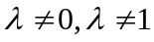 | 13(14.4%) | 18(20%) | 20(22.5%) | 15(16.9%) | 21(23.6%) | 19(21.3%) | 106(19.8%) | 203(25.2%)
Share Returns | 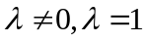 | 16(17.8%) | 12(13.3%) | 11(12.4%) | 13(14.6%) | 11(12.4%) | 10(11.2%) | 73(13.6%) | 126(15.7%)
Share Returns | 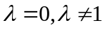 | 29(32.2%) | 30(33.3%) | 26(29.2%) | 26(29.2%) | 25(28.1%) | 23(25.8%) | 159(29.7%) | 201(25%)
Share Returns | 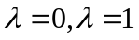 | 32(35.6%) | 30(33.3%) | 32(36.0%) | 35(39.3%) | 32(36%) | 37(41.6%) | 198(36.9%) | 274(34.1%)
Share Returns | Sum | 90 | 90 | 89 | 89 | 89 | 89 | 536 | 804
NAV Returns |  | 36(40%) | - | 26(29.2%) | 35(39.3%) | - | - | 97(36.2%)
NAV Returns |  | 12(13.3%) | - | 24(27%) | 17(19.1%) | - | - | 53(19.8%)
NAV Returns |  | 14(15.6%) | - | 14(15.7%) | 14(15.7%) | - | - | 42(15.7%)
NAV Returns |  | 28(31.1%) | - | 25(28.1%) | 23(25.8%) | - | - | 76(28.4%)
NAV Returns | Sum | 90 | - | 89 | 89 | - | - | 268

Table 4. Correlation Coefficient of Dummy Variables
This table reports the correlation coefficient of three dummy variables of each fund.
 | Em | Reg | SS
EM | 1 | 0.06675 | -0.69308
Reg | 0.06675 | 1 | 0.02349
SS | -0.69308 | 0.02349 | 1

Table 5. Transformation Parameter Summary
This table reports the summary of estimated transformation parameters of each model.
 |  |  | 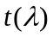 | || | 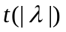
GCAPM  (Share Return) | Mean | 0.218 | 0.369 | 0.994 | 1.577
GCAPM  (Share Return) | Median | 0.282 | 0.495 | 0.801 | 1.335
GCAPM  (Share Return) | STD | 1.248 | 1.928 | 0.778 | 1.158
GCAPM  (Share Return) | Min | -3.798 | -6.310 | 0.001 | 0.000
GCAPM  (Share Return) | Max | 3.162 | 4.380 | 3.798 | 6.310
GCAPM_CRSP  (Share Return) | Mean | 0.026 | -0.029 | 1.030 | 1.668
GCAPM_CRSP  (Share Return) | Median | -0.164 | -0.290 | 0.831 | 1.355
GCAPM_CRSP  (Share Return) | STD | 1.349 | 2.070 | 0.864 | 1.213
GCAPM_CRSP  (Share Return) | Min | -5.320 | -5.610 | 0.006 | 0.020
GCAPM_CRSP  (Share Return) | Max | 2.936 | 4.090 | 5.320 | 5.610
Global Index  (Share Return) | Mean | -0.107 | -0.182 | 1.098 | 1.724
Global Index  (Share Return) | Median | -0.366 | -0.370 | 0.942 | 1.600
Global Index  (Share Return) | STD | 1.405 | 2.086 | 0.875 | 1.174
Global Index  (Share Return) | Min | -5.780 | -5.780 | 0.013 | 0.020
Global Index  (Share Return) | Max | 2.814 | 4.080 | 5.780 | 5.780
Global GCAPM  (Share Return) | Mean | -0.047 | 0.007 | 0.992 | 1.572
Global GCAPM  (Share Return) | Median | 0.130 | 0.110 | 0.817 | 1.330
Global GCAPM  (Share Return) | STD | 1.269 | 1.977 | 0.774 | 1.168
Global GCAPM  (Share Return) | Min | -3.642 | -6.440 | 0.000 | 0.000
Global GCAPM  (Share Return) | Max | 2.395 | 4.100 | 3.642 | 6.440
Global GCAPM_CRSP (Share Return) | Mean | -0.147 | -0.199 | 1.096 | 1.703
Global GCAPM_CRSP (Share Return) | Median | -0.237 | -0.400 | 0.870 | 1.540
Global GCAPM_CRSP (Share Return) | STD | 1.460 | 2.085 | 0.956 | 1.186
Global GCAPM_CRSP (Share Return) | Min | -5.561 | -5.700 | 0.000 | 0.000
Global GCAPM_CRSP (Share Return) | Max | 2.894 | 4.200 | 5.561 | 5.700
Global Carhart GCAPM  (Share Return) | Mean | 0.021 | 0.047 | 0.961 | 1.547
Global Carhart GCAPM  (Share Return) | Median | 0.127 | 0.190 | 0.756 | 1.360
Global Carhart GCAPM  (Share Return) | STD | 1.237 | 1.946 | 0.771 | 1.187
Global Carhart GCAPM  (Share Return) | Min | -3.675 | -6.660 | 0.001 | 0.000
Global Carhart GCAPM  (Share Return) | Max | 2.402 | 4.020 | 3.675 | 6.660
GCAPM  (NAV Return) | Mean | 1.269 | 1.758 | 2.183 | 2.881
GCAPM  (NAV Return) | Median | 1.213 | 1.700 | 1.739 | 2.160
GCAPM  (NAV Return) | STD | 2.769 | 3.331 | 2.116 | 2.415
GCAPM  (NAV Return) | Min | -10.978 | -10.220 | 0.005 | 0.040
GCAPM  (NAV Return) | Max | 12.630 | 11.190 | 12.630 | 11.190
Global Index  (NAV Return) | Mean | 1.185 | 1.786 | 2.303 | 2.617
Global Index  (NAV Return) | Median | 1.599 | 1.880 | 1.770 | 2.030
Global Index  (NAV Return) | STD | 3.833 | 2.735 | 3.278 | 1.944
Global Index  (NAV Return) | Min | -29.013 | -8.790 | 0.012 | 0.110
Global Index  (NAV Return) | Max | 10.668 | 10.590 | 29.013 | 10.590
Global GCAPM  (NAV Return) | Mean | 1.567 | 1.760 | 2.204 | 2.792
Global GCAPM  (NAV Return) | Median | 1.441 | 1.730 | 1.571 | 2.120
Global GCAPM  (NAV Return) | STD | 2.717 | 3.194 | 2.201 | 2.303
Global GCAPM  (NAV Return) | Min | -5.758 | -10.240 | 0.000 | 0.000
Global GCAPM  (NAV Return) | Max | 12.852 | 11.380 | 12.852 | 11.380

Table 6. Cross-Sectional Regressions for Share Return of International CEFs by Group
This table reports the grouped cross-sectional regression of share returns of international closed-end country funds. R_{f} is the one-month T-bill of the U.S. market; R_{m}^{j} is the MSCI country or regional index monthly return corresponding to each international CEF. R_{g} is the MSCI world index monthly return; EM is the dummy variable which is one for emerging country fund and zero for developed country fund; Reg is the dummy variable which is one for regional fund and zero for single country fund; SS is the dummy variable which is one for fund investing in countries where short sale is allowed, and equal to zero for fund investing in countries where short sale is not allowed. MKRF, SMB, HML, and UMD are monthly returns of Carhart four factors. The data spans from 1965 to 2003. White heteroscedasticity consistent t-statistics is in the parentheses. The model estimated is:
Panel A: comparison between emerging market funds and developed market funds
 | Intercept (10⁻³) | R_{f} | R_{m} | R_{g} | R_{mkrf} | R_{smb} | R_{hml} | R_{umd} |  | Share Return
Em=0
Mean |  | 0.00397 | 0.00877 | 0.00766 |  |  |  |  |  | 0.00848
Std. Dev. |  | 0.00161 | 0.0615 | 0.0424 |  |  |  |  |  | 0.0895
Model 1 | -2.17(-1.98)* | 0.029(1.67)** | 0.971(55.38)* |  |  |  |  |  | 0.020(0.26)
Model 1 | -0.146(-0.13) | 0.030(1.66)** | 0.970(53.67)* |  |  |  |  |  | 1
Model 1 | -2.20(-2.04)* | 0.029(1.66)* | 0.971(55.41)* |  |  |  |  |  | 0
Model 2 | -5.09(-4.22)* |  |  | 1.312(47.62)* |  |  |  |  | -0.308(81.3)*
Model 2 | -1.38(-1.11) |  |  | 1.273(44.34)* |  |  |  |  | 1
Model 2 | -4.21(-3.55)* |  |  | 1.300(47.31)* |  |  |  |  | 0
Model 3 | -4.20(-3.87)* |  | 0.666(27.02)* | 0.645(18.41)* |  |  |  |  | -0.142(-1.79)**
Model 3 | -1.70 (-1.53) |  | 0.701(27.78)* | 0.583(15.28)* |  |  |  |  | 1
Model 3 | -3.88 (-3.62)* |  | 0.670(27.26)* | 0.637(18.32)* |  |  |  |  | 0
Model 4 | -5.12 (-3.84)* |  |  |  | 1.244(35.4)* | 0.234(6.0)* | 0.382(7.93)* | 0.0395(1.44) | -0.361(-4.11)*
Model 4 | -1.46(-1.04) |  |  |  | 1.181(31.9)* | 0.221(5.5)* | 0.339(6.75)* | 0.0378(1.29) | 1
Model 4 | -4.16(-3.13)* |  |  |  | 1.224(34.8)* | 0.230(5.9)* | 0.370(7.65)* | 0.0390(1.40) | 0
Model 5 | -4.70(-4.2)* |  | 0.778(36.5)* |  | 0.573(16.4)* | 0.178(5.4)* | 0.229(5.59)* | 0.0160(0.69) | -0.169(-2.12)*
Model 5 | -2.43(-2.05)* |  | 0.808(36.9)* |  | 0.502(13.9)* | 0.169(5.0)* | 0.194(4.57)* | 0.013(0.52) | 1
Model 5 | -4.37(-3.91)* |  | 0.782(36.8)* |  | 0.562(16.2)* | 0.176(5.4)* | 0.224(5.46)* | 0.016(0.67) | 0
Model 6 | -5.49(-4.85)* |  | 0.645(26.0)* | 0.560(10.1)* | 0.197(3.87)* | 0.245(7.4)* | 0.235(5.83)* | 0.014(0.61) | -0.194(-2.45)*
Model 6 | -2.99(-2.56)* |  | 0.681(26.8)* | 0.538(9.43)* | 0.138(2.62)* | 0.233(6.85)* | 0.199(4.76)* | 0.010(0.39) | 1
Model 6 | -4.99 (-4.52)* |  | 0.651(26.3)* | 0.556(10.0)* | 0.187(3.68)* | 0.243(7.34)* | 0.229(5.67)* | 0.013(0.57) | 0
Em=1
Mean |  | 0.00368 | 0.00782 | 0.00756 |  |  |  |  |  | 0.00852
Std. Dev. |  | 0.00134 | 0.1088 | 0.0419 |  |  |  |  |  | 0.1115
Model 1 | 0.580(0.64) | 0.244(29.16)* | 0.756(90.15)* |  |  |  |  |  | 0.325(6.19)*
Model 1 | 1.70(1.85)** | 0.244(28.80)* | 0.756(89.38)* |  |  |  |  |  | 1
Model 1 | 0.041(0.04) | 0.247(29.6)* | 0.753(90.24)* |  |  |  |  |  | 0
Model 2 | -6.54(-5.44)* |  |  | 1.393(50.76)* |  |  |  |  | 0.0696(1.24)
Model 2 | -1.76(-1.47) |  |  | 1.359(48.43)* |  |  |  |  | 1
Model 2 | -6.90(-5.93)* |  |  | 1.397(51.23)* |  |  |  |  | 0
Model 3 | -2.69(-3.05)* |  | 0.643(71.58)* | 0.627(27.04)* |  |  |  |  | 0.187(3.56)*
Model 3 | -1.10(-1.26) |  | 0.652(72.21)* | 0.601(25.57)* |  |  |  |  | 1
Model 3 | -3.10(-3.50)* |  | 0.639(71.73)* | 0.636(27.57)* |  |  |  |  | 0
Model 4 | -5.37(-4.30)* |  |  |  | 1.310(40.6)* | 0.433(12.8)* | 0.321(7.44)* | -0.097(-4.14)* | 0.0342(0.61)
Model 4 | -0.486(-0.38) |  |  |  | 1.263(37.9)* | 0.412(12.0)* | 0.285(6.46)* | -0.117(-4.81)* | 1
Model 4 | -5.54(-4.57)* |  |  |  | 1.312(40.9)* | 0.434(12.8)* | 0.323(7.49)* | -0.096(-4.12)* | 0
Model 5 | -3.07(-3.36)* |  | 0.649(72.2)* |  | 0.625(24.1)* | 0.200(7.84)* | 0.227(7.03)* | 0.013(0.71) | 0.175(3.31)*
Model 5 | -1.79(-1.89)** |  | 0.660(73.0)* |  | 0.598(22.6)* | 0.191(7.45)* | 0.224(6.79)* | 0.006(0.35) | 1
Model 5 | -3.36(-3.70)* |  | 0.646(72.4)* |  | 0.633(24.6)* | 0.202(7.93)* | 0.228(7.09)* | 0.014(0.78) | 0
Model 6 | -3.93 (-4.33)* |  | 0.628(69.3)* | 0.563(12.0)* | 0.167(3.37)* | 0.251(9.82)* | 0.211(6.60)* | 0.013(0.73) | 0.163(3.11)*
Model 6 | -2.56 (-2.72)* |  | 0.640(70.2)* | 0.553(11.7)* | 0.136(2.86)* | 0.241(9.34)* | 0.207(6.35)* | 0.006(0.33) | 1
Model 6 | -4.22 (-4.68)* |  | 0.625(69.5)* | 0.566(12.1)* | 0.163(3.49)* | 0.254(9.92)* | 0.212(6.65)* | 0.014(0.80) | 0

Panel B: comparison between regional funds and single country funds
 | Intercept (10⁻³) | R_{f} | R_{m} | R_{g} | R_{mkrf} | R_{smb} | R_{hml} | R_{umd} |  | Share Return
Reg=0
Mean |  | 0.0038 | 0.00807 | 0.00745 |  |  |  |  |  | 0.00801
Std. Dev. |  | 0.00149 | 0.0999 | 0.0422 |  |  |  |  |  | 0.1061
Model 1 | -0.525(-0.63) | 0.245(29.37)* | 0.755(90.69)* |  |  |  |  |  | -0.131(2.68)*
Model 1 | 0.965(1.14) | 0.239(28.26)* | 0.761(90.15)* |  |  |  |  |  | 1
Model 1 | -0.747(-0.90) | 0.247(29.76)* | 0.753(90.92)* |  |  |  |  |  | 0
Model 2 | -7.47(-7.0)* |  |  | 1.321(54.62)* |  |  |  |  | -0.309(-5.32)*
Model 2 | -1.63(-1.51) |  |  | 1.286(51.06)* |  |  |  |  | 1
Model 2 | -6.08(-5.86)* |  |  | 1.309(54.14)* |  |  |  |  | 0
Model 3 | -3.40(-4.21)* |  | 0.627(69.80)* | 0.632(29.89)* |  |  |  |  | -0.034(-0.68)
Model 3 | -1.50(-1.78)** |  | 0.647(71.42)* | 0.596(27.54)* |  |  |  |  | 1
Model 3 | -3.34 (-4.15)* |  | 0.628(70.73)* | 0.630(30.03)* |  |  |  |  | 0
Model 4 | -6.19(-5.51)* |  |  |  | 1.212(41.8)* | 0.368(11.8)* | 0.293(7.5)* | -0.058(-2.73)* | -0.336(-5.71)*
Model 4 | -0.309(-0.26) |  |  |  | 1.161(37.8)* | 0.346(10.8)* | 0.255(6.3)* | -0.078(-3.42)* | 1
Model 4 | -4.73(-4.29)* |  |  |  | 1.196(41.0)* | 0.362(11.6)* | 0.283(7.2)* | -0.063(-2.92)* | 0
Model 5 | -3.53(-4.19)* |  | 0.648(72.6)* |  | 0.596(25.1)* | 0.193(8.1)* | 0.207(7.0)* | 0.022(1.33) | -0.0399(-0.80)
Model 5 | -1.95(-2.21)* |  | 0.669(74.4)* |  | 0.557(22.7)* | 0.182(7.5)* | 0.201(6.5)* | 0.017(0.97) | 1
Model 5 | -3.46(-4.13)* |  | 0.649(73.7)* |  | 0.594(25.2)* | 0.192(8.1)* | 0.207(6.9)* | 0.022(1.32) | 0
Model 6 | -4.51(-5.43)* |  | 0.615(68.1)* | 0.632(15.7)* | 0.076(1.87)** | 0.256(10.8)* | 0.189(6.44)* | 0.0182(1.12) | -0.057(-1.15)
Model 6 | -2.81(-3.23)* |  | 0.637(70.0)* | 0.625(15.2)* | 0.039(0.94) | 0.244(10.0)* | 0.183(6.02)* | 0.012(0.72) | 1
Model 6 | -4.41(-5.33)* |  | 0.616(69.2)* | 0.631(15.7)* | 0.074(1.82)** | 0.255(10.7)* | 0.189(6.42)* | 0.0179(1.11) | 0
Reg=1
Mean |  | 0.00376 | 0.00738 | 0.00799 |  |  |  |  |  | 0.00943
Std. Dev. |  | 0.00137 | 0.0711 | 0.0418 |  |  |  |  |  | 0.0925
Model 1 | 1.73(1.58) | 0.101(6.72)* | 0.899(59.51)* |  |  |  |  |  | 0.657(7.92)*
Model 1 | -15.9(-9.57)* | 0.052(2.25)* | 0.948(40.70)* |  |  |  |  |  | 1
Model 1 | 0.379(0.35) | 0.094(6.32)* | 0.906(61.17)* |  |  |  |  |  | 0
Model 2 | -2.06(-1.65)** |  |  | 1.3172(45.49)* |  |  |  |  | 0.6950(9.18)*
Model 2 | -0.992(-0.81) |  |  | 1.3039(45.16)* |  |  |  |  | 1
Model 2 | -4.58(-3.73)* |  |  | 1.3587(47.12)* |  |  |  |  | 0
Model 3 | -0.713(-0.66) |  | 0.695(34.59)* | 0.509(14.76)* |  |  |  |  | 0.550(6.75)*
Model 3 | 0.337(0.31) |  | 0.696(34.26)* | 0.495(14.30)* |  |  |  |  | 1
Model 3 | -2.02(-1.89)** |  | 0.698(35.37)* | 0.528(15.39)* |  |  |  |  | 0
Model 4 | -2.66(-2.01)* |  |  |  | 1.318(38.1)* | 0.338(9.32)* | 0.375(8.03)* | -0.026(-0.99) | 0.6162(8.06)*
Model 4 | -1.39(-1.06) |  |  |  | 1.296(37.5)* | 0.329(9.1)* | 0.358(7.66)* | -0.031(-1.16) | 1
Model 4 | -4.75(-3.69)* |  |  |  | 1.364(40.0)* | 0.354(9.68)* | 0.406(8.69)* | -0.017(-0.64) | 0
Model 5 | -2.16(-1.95)** |  | 0.698(38.6)* |  | 0.618(17.9)* | 0.209(6.75)* | 0.283(7.14)* | -0.001(-0.06) | 0.488(6.03)*
Model 5 | -1.12(-1.00) |  | 0.701(38.3)* |  | 0.597(17.2)* | 0.203(6.55)* | 0.269(6.76)* | -0.005(-0.23) | 1
Model 5 | -3.18(-2.92)* |  | 0.698(39.2)* |  | 0.641((18.7)* | 0.215(6.92)* | 0.298(7.52)* | 0.003(0.15) | 0
Model 6 | -2.42 (-2.17)* |  | 0.672(33.5)* | 0.173(2.95)* | 0.494(9.09)* | 0.229(7.23)* | 0.282(7.12)* | -0.002(-0.07) | 0.484(6.0)*
Model 6 | -1.34 (-1.20) |  | 0.675(33.2)* | 0.166(2.81)* | 0.478(8.74)* | 0.221(7.0)* | 0.268(6.74)* | -0.006(-0.26) | 1
Model 6 | -3.45 (-3.16)* |  | 0.673(34.1)* | 0.176(3.00)* | 0.514(9.46)* | 0.236(7.40)* | 0.297(7.50)* | 0.003(0.14) | 0

Panel C: comparison between short sale allowed country funds and short sale not allowed country funds
 | Intercept (10⁻³) | R_{f} | R_{m} | R_{g} | R_{mkrf} | R_{smb} | R_{hml} | R_{umd} |  | Share Return
SS=0
Mean |  | 0.00367 | 0.00663 | 0.00750 |  |  |  |  |  | 0.00784
Std. Dev. |  | 0.00133 | 0.10869 | 0.04198 |  |  |  |  |  | 0.10912
Model 1 | 0.812(0.82) | 0.268(29.25)* | 0.732(80.05)* |  |  |  |  |  | 0.241(4.17)*
Model 1 | 2.00(1.99)* | 0.268(28.97)* | 0.732(79.22)* |  |  |  |  |  | 1
Model 1 | 0.436(0.44) | 0.270(29.6)* | 0.730(80.15)* |  |  |  |  |  | 0
Model 2 | -7.13(-5.6)* |  |  | 1.3857(47.73)* |  |  |  |  | 0.0010(0.02)
Model 2 | -2.34(-1.84)** |  |  | 1.3580(45.54)* |  |  |  |  | 1
Model 2 | -7.13(-5.76)* |  |  | 1.3857(47.93)* |  |  |  |  | 0
Model 3 | -2.63(-2.77)* |  | 0.612(62.77)* | 0.656(26.26)* |  |  |  |  | 0.105(1.81)**
Model 3 | -1.00(-1.06) |  | 0.621(63.24)* | 0.634(24.91)* |  |  |  |  | 1
Model 3 | -2.83(-2.99)* |  | 0.610(63.01)* | 0.661(26.56)* |  |  |  |  | 0
Model 4 | -5.64(-4.25)* |  |  |  | 1.274(37.2)* | 0.424(11.8)* | 0.298(6.5)* | -0.102(-4.1)* | -0.031(-0.5)
Model 4 | -0.78(-0.57) |  |  |  | 1.233(34.6)* | 0.408(11.2)* | 0.266(5.63)* | -0.121(-4.66)* | 1
Model 4 | -5.50(-4.24)* |  |  |  | 1.273(37.3)* | 0.423(11.8)* | 0.287(6.47)* | -0.102(-4.12)* | 0
Model 5 | -2.80(-2.83)* |  | 0.623(64.0)* |  | 0.639(23.0)* | 0.219(7.99)* | 0.226(6.5)* | 0.005(0.27) | 0.099(1.72)**
Model 5 | -1.55(-1.51) |  | 0.633(64.8)* |  | 0.617(21.6)* | 0.216(7.79)* | 0.226(6.4)* | -0.0013(-0.07) | 1
Model 5 | -2.94(-3.0)* |  | 0.621(64.4)* |  | 0.642(23.3)* | 0.220(8.01)* | 0.226(6.5)* | 0.006(0.30) | 0
Model 6 | -3.74(-3.83)* |  | 0.598(60.9)* | 0.617(12.0)* | 0.125(2.47)* | 0.275(10.0)* | 0.208(6.05)* | 0.005(0.29) | 0.089(1.54)
Model 6 | -2.39(-2.35)* |  | 0.608(61.6)* | 0.613(11.7)* | 0.104(2.01)* | 0.270(9.74)* | 0.208(5.90)* | -0.002(-0.08) | 1
Model 6 | -3.89(-4.0)* |  | 0.596(61.2)* | 0.619(12.0)* | 0.128(2.52)* | 0.276(10.1)* | 0.208(6.06)* | 0.006(0.32) | 0
SS=1
Mean |  | 0.00390 | 0.00948 | 0.00774 |  |  |  |  |  | 0.00883
Std. Dev. |  | 0.00156 | 0.06577 | 0.04222 |  |  |  |  |  | 0.08843
Model 1 | -1.27(-1.33) | 0.0957(6.69)* | 0.904(63.24)* |  |  |  |  |  | 0.393(5.49)*
Model 1 | 1.00(1.18) | 0.134(10.43)* | 0.866(67.27)* |  |  |  |  |  | 1
Model 1 | -2.00(-2.14)* | 0.092(6.51)* | 0.908(63.92)* |  |  |  |  |  | 0
Model 2 | -2.17(-1.94)** |  |  | 1.1748(45.53)* |  |  |  |  | 0.3289(4.36)*
Model 2 | -0.125(-0.11) |  |  | 1.1494(44.24)* |  |  |  |  | 1
Model 2 | -3.20(-2.91)* |  |  | 1.1907(46.62)* |  |  |  |  | 0
Model 3 | -2.50(-2.55)* |  | 0.717(38.27)* | 0.458(15.69)* |  |  |  |  | 0.319(4.38)*
Model 3 | -1.00(-1.08) |  | 0.726(38.16)* | 0.429(14.61)* |  |  |  |  | 1
Model 3 | -3.13(3.29)* |  | 0.714(38.3)* | 0.473(16.31)* |  |  |  |  | 0
Model 4 | -3.05(-2.55)* |  |  |  | 1.171(37.2)* | 0.285(8.42)* | 0.364(8.56)* | 0.0497(2.06)* | 0.2549(3.29)*
Model 4 | -1.00(-0.83) |  |  |  | 1.135(35.5)* | 0.271(7.95)* | 0.339(7.89)* | 0.0474(1.92)** | 1
Model 4 | -3.76(-3.21)* |  |  |  | 1.186(38.3)* | 0.291(8.58)* | 0.373(8.8)* | 0.051(2.11)* | 0
Model 5 | -3.73(-3.75)* |  | 0.743(43.5)* |  | 0.508(16.7)* | 0.186(6.54)* | 0.236(6.6)* | 0.035(1.74)** | 0.262(3.6)*
Model 5 | -2.41(-2.38)* |  | 0.753(43.4)* |  | 0.471(15.3)* | 0.175(6.13)* | 0.217(6.01)* | 0.033(1.58) | 1
Model 5 | -4.20(-4.29)* |  | 0.740(43.5)* |  | 0.523(17.4)* | 0.190(6.68)* | 0.243(6.84)* | 0.036(1.8)** | 0
Model 6 | -4.08(-4.11)* |  | 0.695(37.1)* | 0.295(6.11)* | 0.294(6.34)* | 0.220(7.63)* | 0.234(6.60)* | 0.034((1.71)** | 0.255(3.52)*
Model 6 | -2.72(-2.69)* |  | 0.706(37.1)* | 0.286(5.88)* | 0.262(5.60)* | 0.208(7.17)* | 0.215(6.0)* | 0.032(1.54) | 1
Model 6 | -4.55(-4.66)* |  | 0.692(37.2)* | 0.297(6.16)* | 0.306(6.63)* | 0.225(7.77)* | 0.242(6.82)* | 0.035(1.78)** | 0
* Significant at 5% level **Significant at 10% level

Table 7. Cross-Sectional Regressions for NAV Return of International CEFs by Group
This table reports the grouped cross-sectional regression of NAV returns of international closed-end country funds. R_{f} is the one-month T-bill of the U.S. market; R_{m}^{j} is the MSCI country or regional index monthly return corresponding to each international CEF. R_{g} is the MSCI world index monthly return; EM is the dummy variable which is one for emerging country fund and zero for developed country fund; Reg is the dummy variable which is one for regional fund and zero for single country fund; SS is the dummy variable which is one for fund investing in countries where short sale is allowed, and equal to zero for fund investing in countries where short sale is not allowed. The data spans from 1965 to 2003. White heteroscedasticity consistent t-statistics is in the parentheses. The model estimated is:
where
 | Intercept (10⁻³) | R_{f} | R_{m} | R_{g} |  | NAV Return | Intercept (10⁻³) | R_{f} | R_{m} | R_{g} |  | NAV Return
Em=0 |  |  |  |  |  |  | Em=1
Mean |  | 0.00396 | 0.00878 | 0.00776 |  | 0.00189 |  | 0.00366 | 0.00806 | 0.00781 |  | 0.00836
Std. Dev. |  | 0.00162 | 0.0612 | 0.0423 |  | 0.0833 |  | 0.00136 | 0.1084 | 0.0418 |  | 0.2905
Model 1 | -6.04(-6.20)* | 0.188(10.81)* | 0.812(46.54)* |  | 0.610(31.14)* |  | -2.70(-2.61)* | 0.247(25.71)* | 0.753(78.46)* |  | 0.0125(1.64)
Model 1 | -6.04(-5.34)* | 0.190(10.33)* | 0.810(44.02)* |  | 1 |  | 1.60(0.47) | 0.298(9.4)* | 0.702(22.13)* |  | 1
Model 1 | -7.88(-6.33) | 0.188(9.34)* | 0.812(40.25)* |  | 0 |  | -2.76(-2.64)* | 0.247(25.69)* | 0.753(78.51)* |  | 0
Model 2 | -5.69(-4.50)* |  |  | 0.856(29.15)* | 0.561(25.05)* |  | -81.8(-27.18)* |  |  | 0.807(16.80)* | -0.391(-35.5)*
Model 2 | -4.58(-3.43)* |  |  | 0.848(27.28)* | 1 |  | 1.39(0.67) |  |  | 0.831(17.13)* | 1
Model 2 | -7.38(-5.29)* |  |  | 0.872(26.97)* | 0 |  | -6.61(-4.80)* |  |  | 0.944(29.26)* | 0
Model 3 | -5.70(-5.05)* |  | 0.743(28.96)* | 0.121(3.31)* | 0.574(28.85)* |  | -2.58(-2.56)* |  | 0.748(68.45)* | 0.0616(2.91)* | 0.0137(1.69)**
Model 3 | -4.93(-4.09)* |  | 0.749(27.49)* | 0.109(2.80)* | 1 |  | -1.27(-0.85) |  | 0.744(48.81)* | 0.0204(0.53) | 1
Model 3 | -6.88(-5.40) |  | 0.723(24.39)* | 0.152(3.52)* | 0 |  | -2.61(-2.25)* |  | 0.748(68.48)* | 0.0618(2.35)* | 0
Reg=0 |  |  |  |  |  |  | Reg=1
Mean |  | 0.00378 | 0.00826 | 0.00763 |  | 0.00685 |  | 0.00373 | 0.00747 | 0.00814 |  | 0.00349
Std. Dev. |  | 0.0015 | 0.0996 | 0.0421 |  | 0.2732 |  | 0.00138 | 0.0710 | 0.0416 |  | 0.0725
Model 1 | -4.36(-4.32)* | 0.239(23.55)* | 0.761(74.81)* |  | 0.073(10.18)* |  | -2.32(-2.82)* | 0.283(24.12)* | 0.717(60.98)* |  | 1.737(16.97)*
Model 1 | -0.123(-0.04) | 0.288(9.5)* | 0.712(23.5)* |  | 1 |  | -2.98(-3.64)* | 0.266(23.13)* | 0.734(63.76)* |  | 1
Model 1 | -4.58(-4.5)* | 0.238(23.26)* | 0.762(74.56)* |  | 0 |  | -3.84(-4.54)* | 0.252(21.76)* | 0.748(64.7)* |  | 0
Model 2 | -5.93(-4.70)* |  |  | 0.859(29.26)* | 0.099(10.09)* |  | -2.11(-2.13)* |  |  | 0.940(41.0)* | 2.200(19.35)*
Model 2 | -0.336(-0.22) |  |  | 0.801(22.98)* | 1 |  | -4.35(-4.44)* |  |  | 0.963(41.56)* | 1
Model 2 | -6.55(-5.15)* |  |  | 0.865(29.21)* | 0 |  | -6.38(-6.28)* |  |  | 0.992(41.32)* | 0
Model 3 | -3.50(-3.38)* |  | 0.742(64.17)* | 0.078(2.87)* | 0.068(9.47)* |  | -2.40(-2.9)* |  | 0.615(39.32)* | 0.250(9.53)* | 1.864(17.54)*
Model 3 | 1.40(0.45) |  | 0.708(20.38)* | 0.0056(0.07) | 1 |  | -3.20(-3.84)* |  | 0.641(41.2)* | 0.230(8.67)* | 1
Model 3 | -3.80(-3.57)* |  | 0.743(63.93)* | 0.081(2.93)* | 0 |  | -4.10(-4.78)* |  | 0.662(42.2)* | 0.220(8.03)* | 0
SS=0 |  |  |  |  |  |  | SS=1
Mean |  | 0.00366 | 0.00656 | 0.00762 |  | 0.00799 |  | 0.00389 | 0.00959 | 0.00796 |  | 0.00291
Std. Dev. |  | 0.00134 | 0.1083 | 0.0419 |  | 0.3139 |  | 0.00157 | 0.0656 | 0.0421 |  | 0.0848
Model 1 | -2.27(-1.96)* | 0.268(25.08)* | 0.732(68.5)* |  | 0.012(1.52) |  | -6.23(-6.6)* | 0.1979(13.87)* | 0.802(56.25)* |  | 0.594(30.74)*
Model 1 | 2.37(0.57) | 0.323(8.52)* | 0.677(17.83)* |  | 1 |  | -5.52(-5.59)* | 0.204(13.58)* | 0.796(53.13)* |  | 1
Model 1 | -2.30(-1.98)* | 0.268(25.07)* | 0.732(68.54)* |  | 0 |  | -7.40(-6.99)* | 0.189(11.94)* | 0.811(51.19)* |  | 0
Model 2 | -6.74(-4.50)* |  |  | 0.918(26.22)* | 0.021(2.07)* |  | -4.96(-4.35)* |  |  | 0.870(32.68)* | 0.571(25.14)*
Model 2 | -0.342(0.14) |  |  | 0.826(14.37)* | 1 |  | -3.76(-3.17)* |  |  | 0.860(30.99)* | 1
Model 2 | -6.87(-4.59)* |  |  | 0.919(26.27)* | 0 |  | -6.77(-5.49)* |  |  | 0.896(31.12)* | 0
Model 3 | -2.167(-1.95)** |  | 0.723(64.78)* | 0.070(2.41)* | 0.0129(1.59) |  | -5.490(-5.58)* |  | 0.741(38.57)* | 0.1318(4.34)* | 0.561(28.69)*
Model 3 | 3.70(0.88) |  | 0.680(16.0)* | -0.023(-0.21) | 1 |  | -4.70(-4.51)* |  | 0.738(36.28)* | 0.125(3.97)* | 1
Model 3 | -1.80(-1.57) |  | 0.717(59.6)* | 0.080(2.61)* | 0 |  | -6.60(-6.07)* |  | 0.746(34.98)* | 0.138(4.14)* | 0
* Significant at 5% level **Significant at 10% level
Table 8. Cross-Sectional Pooled Regressions for Share Return of International CEFs
This table reports the cross-sectional pooled regression of share returns of international closed-end country funds. R_{f} is the one-month T-bill of the U.S. market; R_{m}^{j} is the MSCI country or regional index monthly return corresponding to each international CEF. R_{g} is the MSCI world index monthly return; EM is the dummy variable which is one for emerging country fund and zero for developed country fund; Reg is the dummy variable which is one for regional fund and zero for single country fund; SS is the dummy variable which is one for fund investing in countries where short sale is allowed, and equal to zero for fund investing in countries where short sale is not allowed. MKRF, SMB, HML, and UMD are monthly returns of Carhart four factors. The data spans from 1965 to 2003. White heteroscedasticity consistent t-statistics is in the parentheses. The model estimated is:
where
 | Intercept (10⁻³) | R_{f} | R_{m} | R_{g} | R_{mkrf} | R_{smb} | R_{hml} | R_{umd} | Em | Reg | SS
Mean |  | 3.73e-3 | 7.59e-3 | 7.64e-3 |  |  |  |  | 0.668 | 0.342 | 0.444
Std. Dev. |  | 1.39e-3 | 0.0917 | 0.042 |  |  |  |  | 0.471 | 0.474 | 0.497
Panel A 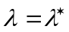
Model 1 | 0.189 (0.28) | 0.212 (29.32)* | 0.788 (108.8)* |  |  |  |  |  |  |  |  | 0.280 (6.82)*
Model 2 | -2.65(-4.09)* |  | 0.642 (79.26)* | 0.605 (34.4)* |  |  |  |  |  |  |  | 0.132 (3.18)*
Model 3 | -3.50(-2.96)* |  | 0.644 (78.64)* | 0.638 (34.47)* |  |  |  |  | 0.0006 (0.42) |  |  | 0.108 (2.50)*
Model 4 | -3.0(-3.77)* |  | 0.642 (79.25)* | 0.605 (34.39)* |  |  |  |  |  | 9.79e-4 (0.73) |  | 0.132 (3.19)*
Model 5 | -2.10(-2.34)* |  | 0.633 (74.93)* | 0.593 (32.27)* |  |  |  |  |  |  | -9.34e-4 (-0.70) | 0.182 (4.06)*
Model 6 | -2.60(-1.21) |  | 0.634 (74.83)* | 0.631 (33.08)* |  |  |  |  | 8.03e-5 (0.04) | -3.85e-4 (-0.23) | -8.64e-4 (-0.43) | 0.148 (3.19)*
Model 7 | -4.75(-5.47)* |  |  |  | 1.254(55.5)* | 0.359(14.9)* | 0.324(10.6)* | -0.048(-2.83)* |  |  |  | -0.011(-0.24)
Model 8 | -5.70(-2.05)* |  |  |  | 1.256(49.5)* | 0.372(13.8)* | 0.320(9.38)* | -0.046(-2.43)* | -3.68e-4(-0.14) | 3.97e-4(0.18) | 2.37e-3(0.92) | 0.032(0.64)
Model 9 | -3.18(-4.74)* |  | 0.660(83.8)* |  | 0.613(31.7)* | 0.200(10.5)* | 0.237(9.91)* | 0.015(1.16) |  |  |  | 0.110(2.66)*
Model 10 | -2.88(-1.34) |  | 0.652(78.4)* |  | 0.623(29.5)* | 0.196(9.39)* | 0.227(8.66)* | 0.021(1.44) | 8.70e-6(0.00) | -5.58e-4(-0.33) | -1.05e-3(-0.53) | 0.135(2.89)*
Model 11 | -3.93(-5.89)* |  | 0.626(77.2)* | 0.494(15.1)* | 0.215(6.58)* | 0.250(13.1)* | 0.225(9.51)* | 0.013(0.98) |  |  |  | 0.097(2.34)*
Model 12 | -3.86(-1.83)** |  | 0.619(72.8)* | 0.557(15.3)* | 0.170(4.69)* | 0.252(12.0)* | 0.213(8.23)* | 0.019(1.30) | 4.29e-5(0.02) | -2.89e-4(-0.18) | -8.31e-4(-0.42) | 0.123(2.64)*
Panel B 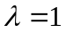
Model 1 | 1.51(2.24)* | 0.212 (28.85)* | 0.788 (107.5)* |  |  |  |  |  |  |  |  | 1
Model 2 | -0.89(-1.35) |  | 0.654 (80.00)* | 0.574 (32.17)* |  |  |  |  |  |  |  | 1
Model 3 | -1.53(-1.26) |  | 0.656 (79.29)* | 0.606 (32.25)* |  |  |  |  | 3.25e-4 (0.22) |  |  | 1
Model 4 | -1.36(-1.69) |  | 0.654 (80.01)* | 0.574 (32.16)* |  |  |  |  |  | 1.38e-3 (1.01) |  | 1
Model 5 | -0.662(-0.72) |  | 0.641 (75.28)* | 0.568 (30.52)* |  |  |  |  |  |  | -6.93e-4 (-0.51) | 1
Model 6 | -1.083(-0.50) |  | 0.642 (75.10)* | 0.605 (31.28)* |  |  |  |  | -1.87e-4 (-0.09) | 3.61e-4 (0.21) | -5.96e-4 (-0.29) | 1
Model 7 | -0.649(-0.73) |  |  |  | 1.207(51.5)* | 0.340(13.9)* | 0.289(9.24)* | -0.062(-3.55)* |  |  |  | 1
Model 8 | -2.39(-0.84) |  |  |  | 1.213(46.3)* | 0.355(13.0)* | 0.289(8.30)* | -0.057(-2.92)* | 1.11e-3(0.41) | 3.16e-5(-0.01) | 1.72e-3(0.65) | 1
Model 9 | -1.67(-2.40)* |  | 0.674(84.7)* |  | 0.577(29.2)* | 0.190(9.91)* | 0.225(9.20)* | 0.0097(0.71) |  |  |  | 1
Model 10 | -1.62(-0.74) |  | 0.661(78.8)* |  | 0.595(27.5)* | 0.190(9.02)* | 0.221(8.22)* | 0.017(1.12) | -4.01e-4(-0.19) | 2.45e-4(0.14) | -7.37e-4(-0.36) | 1
Model 11 | -2.31(-3.35)* |  | 0.641(78.2)* | 0.486(14.6)* | 0.184(5.5)* | 0.239(12.4)* | 0.213(8.78)* | 6.45e-3(0.47) |  |  |  | 1
Model 12 | -2.56(-1.18) |  | 0.629(73.3)* | 0.552(14.9)* | 0.143(3.87)* | 0.244(11.6)* | 0.206(7.77)* | 0.014(0.94) | -2.47e-4(-0.12) | 4.72e-4(0.28) | -5.6e-4(-0.28) | 1
Panel C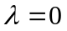
Model 1 | -0.317(-0.48) | 0.214 (29.71)* | 0.786 (109.1)* |  |  |  |  |  |  |  |  | 0
Model 2 | -2.93(-4.56)* |  | 0.639 (79.49)* | 0.612 (35.03)* |  |  |  |  |  |  |  | 0
Model 3 | -3.75(-3.18)* |  | 0.642 (78.93)* | 0.644 (35.01)* |  |  |  |  | 6.25e-4 (0.44) |  |  | 0
Model 4 | -3.25(-4.11)* |  | 0.639 (79.48)* | 0.612 (35.03)* |  |  |  |  |  | 9.11e-4 (0.68) |  | 0
Model 5 | -2.46(-2.73)* |  | 0.630 (75.01)* | 0.602 (32.93)* |  |  |  |  |  |  | -9.83e-4 (-0.73) | 0
Model 6 | -2.84(-1.34) |  | 0.631 (74.98)* | 0.638 (33.64)* |  |  |  |  | 1.11e-4 (0.05) | -5.29e-4 (-0.32) | -9.19e-4 (-0.46) | 0
Model 7 | -4.70(-5.53)* |  |  |  | 1.253(55.8)* | 0.359(14.9)* | 0.324(10.6)* | -0.048(-2.84)* |  |  |  | 0
Model 8 | -5.80(-2.09)* |  |  |  | 1.258(49.9)* | 0.372(13.8)* | 0.321(9.43)* | -0.045(-2.41)* | -4.21e-4(-0.16) | 4.05e-4(0.19) | 2.39e-3(0.92) | 0
Model 9 | -3.38(-5.07)* |  | 0.658(84.1)* |  | 0.619(32.3)* | 0.201(10.6)* | 0.239(10.0)* | 0.016(1.21) |  |  |  | 0
Model 10 | -3.06(-1.43) |  | 0.650(78.6)* |  | 0.630(30.0)* | 0.197(9.45)* | 0.229(8.73)* | 0.021(1.48) | 5.85e-5(0.03) | -6.95e-4(-0.42) | -1.11e-3(-0.56) | 0
Model 11 | -4.11(-6.2)* |  | 0.624(77.5)* | 0.496(15.1)* | 0.219(6.7)* | 0.252(13.2)* | 0.227(9.6)* | 0.013(1.03) |  |  |  | 0
Model 12 | -4.04(-1.91)** |  | 0.617(73.0)* | 0.558(15.3)* | 0.174(4.81)* | 0.253(12.1)* | 0.215(8.29)* | 0.019(1.34) | 7.03e-5(0.03) | -4.06e-4(-0.25) | -8.76e-4(-0.44) | 0
* Significant at 5% level
Table 9. Cross-Sectional Pooled Regressions for NAV Return of International CEFs
This table reports the cross-sectional pooled regression of NAV returns of international closed-end country funds. Rf is the one-month T-bill of the U.S. market; Rmj is the MSCI country or regional index monthly return corresponding to each international CEF. Rg is the MSCI world index monthly return; EM is the dummy variable which is one for emerging country fund and zero for developed country fund; Reg is the dummy variable which is one for regional fund and zero for single country fund; SS is the dummy variable which is one for fund investing in countries where short sale is allowed, and equal to zero for fund investing in countries where short sale is not allowed. The data spans from 1965 to 2003. White heteroscedasticity consistent t-statistics is in the parentheses. The model estimated is:
where
 | Intercept (10⁻³) | R_{f} | R_{m} | R_{g} | Em | Reg | SS |  | NAV Return
Mean |  | 3.71e-3 | 7.81e-3 | 7.80e-3 | 0.671 | 0.341 | 0.441 |  | 5.88e-3
Std. Dev. |  | 1.40e-3 | 0.0915 | 0.0419 | 0.470 | 0.474 | 0.496 |  | 0.229
Panel A
Model 1 | -4.16(-5.71)* | 0.242 (30.33)* | 0.758 (94.89)* |  |  |  |  | 0.076 (12.06)*
Model 2 | -3.63(-4.85)* |  | 0.730 (78.02)* | 0.107 (5.27)* |  |  |  | 0.072 (11.31)*
Model 3 | -6.49(-4.56)* |  | 0.736 (75.11)* | 0.100 (4.52)* | 0.00417 (2.41)* |  |  | 0.071 (10.75)*
Model 4 | -3.68(-4.01)* |  | 0.730 (78.02)* | 0.107 (5.27)* |  | 1.42e-4 (0.09) |  | 0.072 (11.30)*
Model 5 | -1.88(-1.75)** |  | 0.720 (71.59)* | 0.112 (5.12)* |  |  | -0.00424 (-2.64)* | 0.072 (10.96)*
Model 6 | -4.01(-1.52) |  | 0.724 (69.48)* | 0.108 (4.59)* | 0.00245 (0.98) | -6.92e-4 (-0.34) | -0.00283 (-1.15) | 0.070 (10.51)*
Panel B
Model 1 | -1.07(-0.52) | 0.283 (12.71)* | 0.717 (32.14)*
Model 2 | -0.086(-0.04) |  | 0.699 (26.63)* | 0.064 (1.12)
Model 3 | -4.12(-1.00) |  | 0.704 (25.01)* | 0.051 (0.80) | 0.00641 (1.29)
Model 4 | 1.04(0.40) |  | 0.699 (26.62)* | 0.0646 (1.13) |  | -0.00329 (-0.75)
Model 5 | 3.02(0.95) |  | 0.688 (23.43)* | 0.059 (0.92) |  |  | -0.00673 (-1.42)
Model 6 | 0.682(0.09) |  | 0.692 (22.34)* | 0.0488 (0.70) | 0.00404 (0.54) | -0.00477 (-0.78) | -0.00452 (-0.61)
Panel C
Model 1 | -4.34(-5.91)* | 0.241(30.01)* | 0.759(94.65)*
Model 2 | -3.81(-5.06)* |  | 0.731 (77.80)* | 0.109 (5.31)*
Model 3 | -6.68(-4.67)* |  | 0.737(74.88)* | 0.102(4.57)* | 0.00416(2.39)*
Model 4 | -3.91(-4.24)* |  | 0.731 (77.79)* | 0.109 (5.31)* |  | 3.01e-4 (0.19)
Model 5 | -2.08(-1.91)** |  | 0.721 (71.35)* | 0.114 (5.18)* |  |  | -0.00423 (-2.61)*
Model 6 | -4.22(-1.60) |  | 0.725 (69.24)* | 0.110 (4.64)* | 0.00243 (0.96) | -5.22e-4 (-0.25) | -0.00284 (-1.14)
* Significant at 5% level **Significant at 10% level
Table 10. Performance Evaluation of International CEFs
This table gives the summary statistics of estimated alphas and betas for functional form, linear and loglinear specification of different models.
 |  | 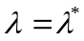 |  |  |  |  |  | 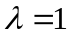
 |  | (%) | 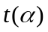 | 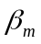 | 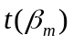 | 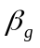 | 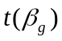 | (%) |  |  |  |  |  | (%)
GCAPM  (Share Return) | Mean | -0.11 | -0.13 | 0.87 | 12.20 |  |  | 0.05 | 0.13 | 0.88 | 12.08 |  |  | -0.13 | -0.16 | 0.89 | 12.33
GCAPM  (Share Return) | Median | -0.16 | -0.31 | 0.89 | 12.33 |  |  | 0.05 | 0.12 | 0.90 | 12.33 |  |  | -0.12 | -0.17 | 0.90 | 12.37
GCAPM  (Share Return) | STD | 0.61 | 0.85 | 0.25 | 4.72 |  |  | 0.59 | 0.86 | 0.24 | 4.63 |  |  | 0.60 | 0.84 | 0.25 | 4.71
GCAPM  (Share Return) | Min | -2.80 | -1.77 | 0.21 | 1.02 |  |  | -2.00 | -1.77 | 0.20 | 1.05 |  |  | -2.44 | -1.82 | 0.23 | 1.19
GCAPM  (Share Return) | Max | 1.54 | 2.17 | 1.76 | 27.40 |  |  | 1.88 | 2.53 | 1.64 | 25.45 |  |  | 1.65 | 2.33 | 1.71 | 26.92
GCAPM_CRSP  (Share Return) | Mean | -0.80 | -0.85 | 1.16 | 6.84 |  |  | -0.38 | -0.34 | 1.13 | 6.58 |  |  | -0.82 | -0.90 | 1.19 | 7.04
GCAPM_CRSP  (Share Return) | Median | -0.51 | -0.74 | 1.12 | 7.06 |  |  | -0.17 | -0.26 | 1.12 | 6.46 |  |  | -0.55 | -0.79 | 1.20 | 7.02
GCAPM_CRSP  (Share Return) | STD | 1.11 | 1.11 | 0.31 | 2.39 |  |  | 0.95 | 1.02 | 0.30 | 2.35 |  |  | 0.98 | 0.98 | 0.32 | 2.49
GCAPM_CRSP  (Share Return) | Min | -3.87 | -3.65 | 0.39 | 1.42 |  |  | -4.12 | -3.69 | 0.34 | 1.28 |  |  | -4.98 | -4.16 | 0.37 | 1.46
GCAPM_CRSP  (Share Return) | Max | 1.41 | 2.03 | 2.15 | 13.90 |  |  | 1.70 | 3.28 | 2.12 | 13.82 |  |  | 1.37 | 2.81 | 2.29 | 14.52
GCAPM  (NAV Return) | Mean | -0.33 | -0.90 | 0.77 | 15.05 |  |  | -0.14 | -0.91 | 0.76 | 14.72 |  |  | -0.44 | -1.04 | 0.79 | 14.93
GCAPM  (NAV Return) | Median | -0.38 | -0.91 | 0.79 | 15.19 |  |  | -0.39 | -0.95 | 0.80 | 14.40 |  |  | -0.45 | -1.08 | 0.80 | 13.95
GCAPM  (NAV Return) | STD | 0.52 | 1.14 | 0.19 | 7.14 |  |  | 1.84 | 1.24 | 0.27 | 7.38 |  |  | 0.62 | 1.16 | 0.19 | 7.57
GCAPM  (NAV Return) | Min | -2.59 | -4.00 | 0.20 | 1.34 |  |  | -2.29 | -4.00 | -1.05 | -0.72 |  |  | -3.38 | -4.14 | 0.27 | 1.22
GCAPM  (NAV Return) | Max | 1.24 | 1.66 | 1.47 | 33.55 |  |  | 16.24 | 1.69 | 1.51 | 31.82 |  |  | 0.77 | 1.70 | 1.49 | 34.99
Global Index  (Share Return) | Mean | -0.75 | -0.85 |  |  | 1.32 | 8.10 | -0.32 | -0.30 |  |  | 1.30 | 7.78 | -0.73 | -0.84 |  |  | 1.34 | 8.18
Global Index  (Share Return) | Median | -0.51 | -0.78 |  |  | 1.33 | 7.87 | -0.11 | -0.21 |  |  | 1.34 | 7.49 | -0.45 | -0.73 |  |  | 1.35 | 8.04
Global Index  (Share Return) | STD | 1.11 | 1.18 |  |  | 0.36 | 3.06 | 0.89 | 0.99 |  |  | 0.35 | 2.99 | 0.96 | 1.01 |  |  | 0.37 | 3.06
Global Index  (Share Return) | Min | -3.80 | -3.69 |  |  | 0.37 | 1.48 | -3.55 | -3.53 |  |  | 0.33 | 1.50 | -4.32 | -4.00 |  |  | 0.36 | 1.64
Global Index  (Share Return) | Max | 1.31 | 1.62 |  |  | 2.33 | 16.92 | 1.62 | 1.63 |  |  | 2.31 | 16.56 | 1.53 | 1.61 |  |  | 2.47 | 16.95
Global Index  (NAV Return) | Mean | -0.41 | -0.59 |  |  | 0.91 | 6.36 | -0.16 | -0.67 |  |  | 0.84 | 6.27 | -0.75 | -1.08 |  |  | 0.93 | 6.37
Global Index  (NAV Return) | Median | -0.32 | -0.61 |  |  | 0.92 | 6.37 | -0.27 | -0.60 |  |  | 0.93 | 6.24 | -0.52 | -0.92 |  |  | 0.94 | 6.34
Global Index  (NAV Return) | STD | 0.84 | 0.96 |  |  | 0.37 | 2.76 | 2.40 | 0.93 |  |  | 0.80 | 2.93 | 0.75 | 0.83 |  |  | 0.33 | 2.86
Global Index  (NAV Return) | Min | -3.91 | -2.74 |  |  | -0.13 | -0.30 | -2.91 | -3.50 |  |  | -6.04 | -1.47 | -3.73 | -3.73 |  |  | -0.08 | -0.35
Global Index  (NAV Return) | Max | 1.90 | 1.49 |  |  | 2.94 | 13.74 | 21.18 | 1.26 |  |  | 1.61 | 13.96 | 0.29 | 0.30 |  |  | 1.63 | 13.95
Global GCAPM  (Share Return) | Mean | -0.42 | -0.59 | 0.68 | 8.30 | 0.56 | 3.45 | -0.19 | -0.23 | 0.70 | 8.95 | 0.52 | 2.86 | -0.40 | -0.58 | 0.68 | 8.85 | 0.57 | 3.20
Global GCAPM  (Share Return) | Median | -0.35 | -0.66 | 0.66 | 8.31 | 0.56 | 3.57 | -0.12 | -0.26 | 0.72 | 8.40 | 0.50 | 3.12 | -0.34 | -0.58 | 0.69 | 8.72 | 0.52 | 3.26
Global GCAPM  (Share Return) | STD | 0.79 | 0.97 | 0.37 | 4.53 | 0.41 | 1.77 | 0.70 | 0.93 | 0.34 | 4.91 | 0.39 | 2.21 | 0.74 | 0.95 | 0.36 | 4.98 | 0.40 | 1.99
Global GCAPM  (Share Return) | Min | -3.88 | -3.30 | -1.21 | -1.62 | -0.70 | -1.98 | -2.67 | -2.57 | -1.14 | -1.62 | -0.55 | -7.78 | -3.00 | -2.81 | -1.22 | -1.68 | -0.62 | -2.36
Global GCAPM  (Share Return) | Max | 1.32 | 1.62 | 2.27 | 23.27 | 1.86 | 8.52 | 1.64 | 1.99 | 2.04 | 26.16 | 1.75 | 8.52 | 1.55 | 1.78 | 2.14 | 26.48 | 1.89 | 8.49
Global GCAPM_CRSP  (Share Return) | Mean | -0.76 | -0.83 | -0.07 | -0.14 | 1.40 | 4.08 | -0.31 | -0.27 | -0.09 | -0.21 | 1.39 | 3.99 | -0.74 | -0.83 | -0.06 | -0.13 | 1.41 | 4.05
Global GCAPM_CRSP  (Share Return) | Median | -0.45 | -0.75 | -0.01 | -0.04 | 1.40 | 3.99 | -0.11 | -0.14 | -0.05 | -0.10 | 1.38 | 3.79 | -0.45 | -0.66 | -0.01 | -0.01 | 1.39 | 3.96
Global GCAPM_CRSP  (Share Return) | STD | 1.10 | 1.15 | 0.59 | 1.45 | 0.67 | 2.13 | 0.91 | 0.97 | 0.59 | 1.43 | 0.66 | 2.11 | 0.97 | 0.98 | 0.60 | 1.45 | 0.66 | 2.10
Global GCAPM_CRSP  (Share Return) | Min | -4.02 | -3.79 | -2.44 | -3.42 | -0.57 | -1.19 | -3.48 | -3.16 | -2.26 | -3.13 | -0.51 | -1.08 | -4.37 | -3.69 | -2.35 | -3.33 | -0.27 | -0.52
Global GCAPM_CRSP  (Share Return) | Max | 1.30 | 1.66 | 1.18 | 3.10 | 4.25 | 10.67 | 1.12 | 1.33 | 1.20 | 2.67 | 3.97 | 10.87 | 1.00 | 1.18 | 1.27 | 2.74 | 4.10 | 10.67
Global GCAPM  (NAV Return) | Mean | -0.30 | -0.83 | 0.72 | 11.81 | 0.11 | 0.73 | -0.06 | -0.90 | 0.72 | 11.57 | 0.05 | 0.63 | -0.43 | -1.04 | 0.74 | 11.69 | 0.11 | 0.56
Global GCAPM  (NAV Return) | Median | -0.30 | -0.71 | 0.74 | 10.94 | 0.08 | 0.73 | -0.33 | -0.80 | 0.75 | 10.82 | 0.07 | 0.61 | -0.41 | -0.96 | 0.77 | 10.91 | 0.07 | 0.59
Global GCAPM  (NAV Return) | STD | 0.52 | 1.22 | 0.25 | 6.84 | 0.26 | 1.92 | 2.40 | 1.51 | 0.28 | 6.97 | 0.69 | 1.80 | 0.64 | 1.44 | 0.27 | 7.06 | 0.30 | 1.78
Global GCAPM  (NAV Return) | Min | -2.40 | -7.61 | 0.04 | 0.20 | -0.94 | -10.50 | -2.52 | -10.55 | -0.28 | -0.18 | -5.79 | -9.08 | -3.70 | -10.37 | 0.08 | 0.30 | -0.94 | -8.43
Global GCAPM  (NAV Return) | Max | 1.50 | 1.60 | 1.80 | 30.55 | 0.98 | 6.45 | 21.63 | 1.64 | 1.84 | 27.56 | 1.00 | 4.15 | 0.86 | 1.65 | 1.86 | 31.47 | 1.10 | 4.68

Figure 1. Histogram of Estimated Functional Form Parameter
This figure shows the distribution of estimated lambda of each model for international closed-end fund share return and NAV return. The curve in each graph is the standard normal distribution with mean 0 and variance 1.
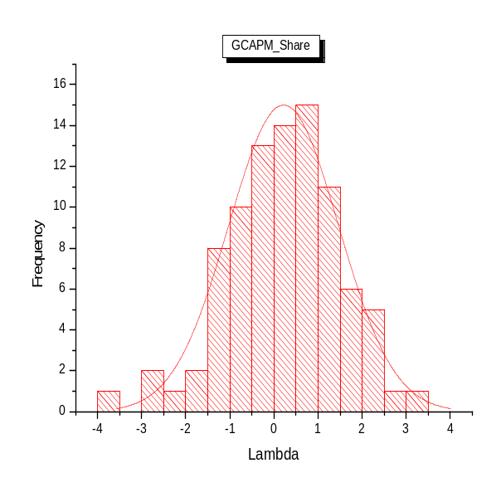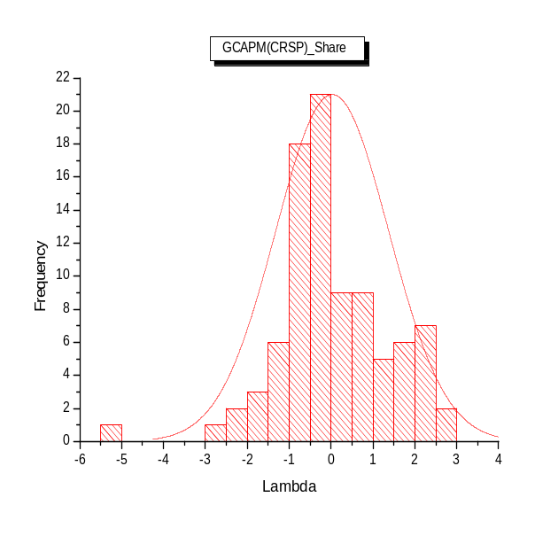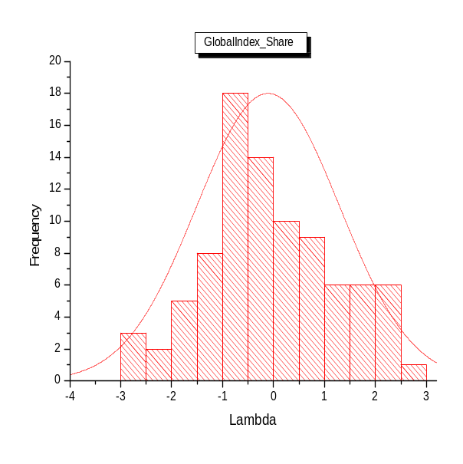
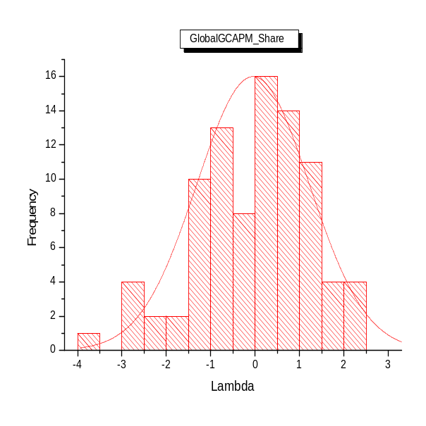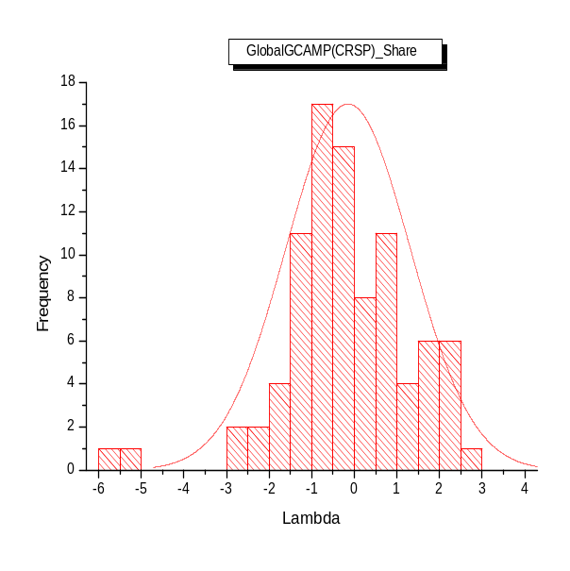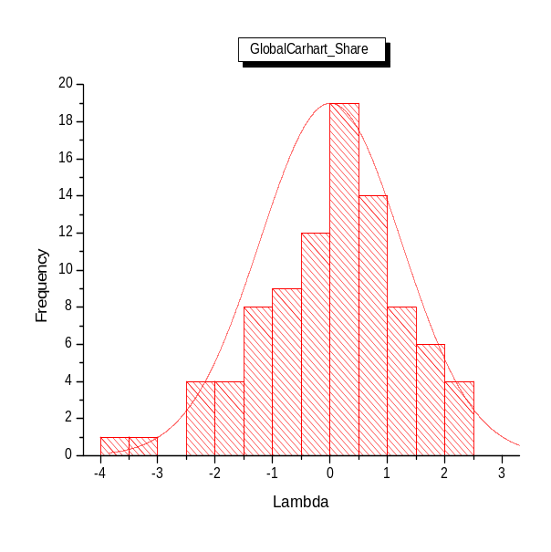
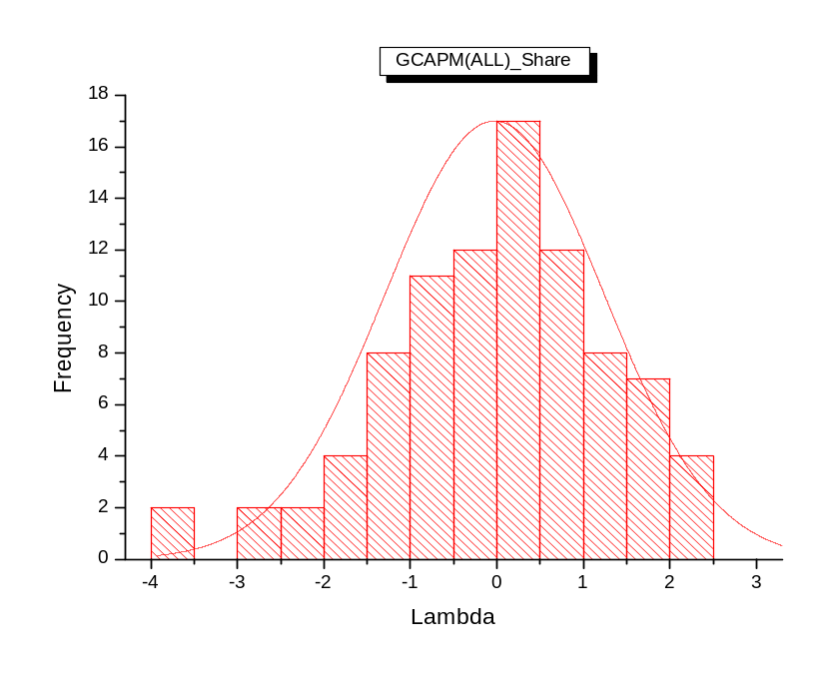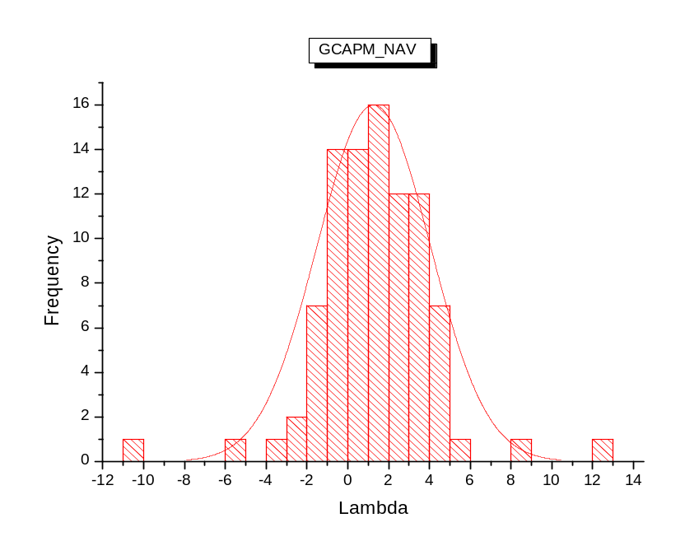
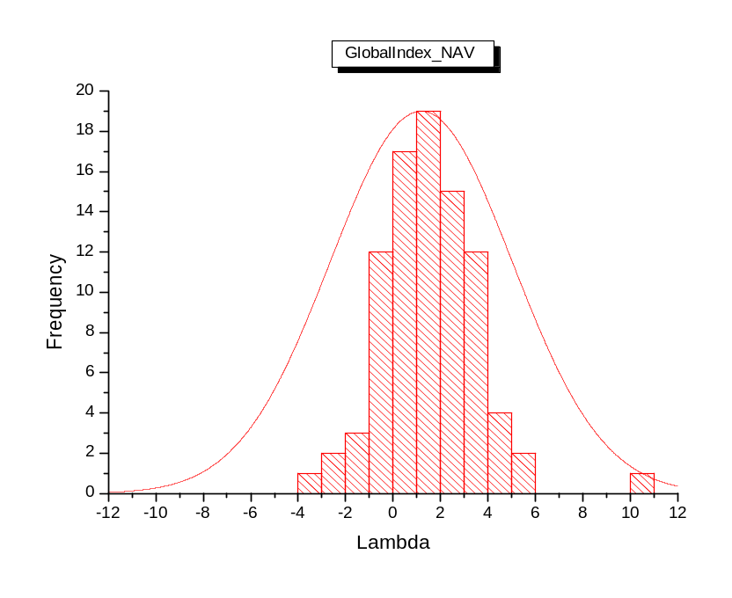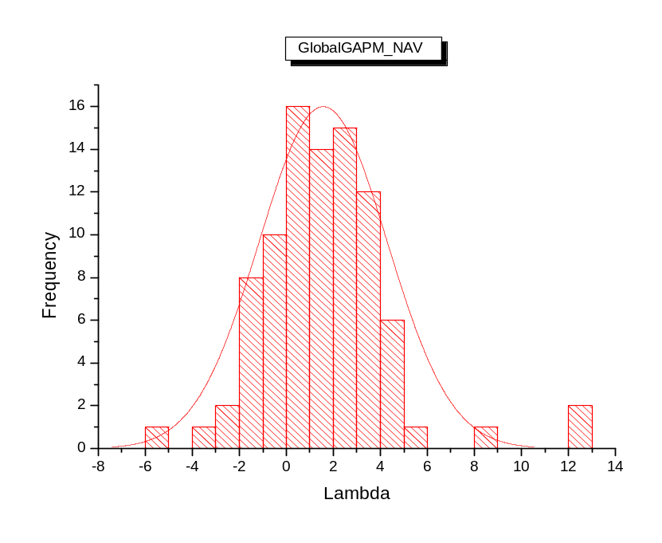

* We would like to thank Ren-Raw Chen, Ben Sopranzetti, Louis Scott and participants in ASSA 2005 Annual Meeting in Philadelphia for helpful comments.
† Distinguished professor of Rutgers Business School, Department of Finance and Economics, 94 Rockafeller Road, Piscataway, NJ, 08854, Tel: 732-445-3530, Fax: 732-445-5927, Email: Lee@rbsmail.rutgers.edu
‡ Assistant professor of Rutgers Business School, Department of Finance and Economics, 111 Washington St., Newark, NJ, 07102, Tel: 973-353-5709, Email: dilipk@andromeda.rutgers.edu
§ Ph.D. candidate, Rutgers Business School, Department of Finance and Economics, 94 Rockafeller Road, Piscataway, NJ, 08854, Tel: 973-580-5817, Email: boliu@andromeda.rutgers.edu
 Department of FinancAliceLee@sfsu.edu. (415)338-1701.
Information of short sale policy comes from Bris, Goetzmann and Zhu (2004).
Morgan Stanley started the emerging market index from 1988, therefore our global index (including developed and emerging markets) starts from Jan. 1988.
Although we admit that all of international CEFs in our sample are U.S. traded securities, the evidence from NAV return still provides some support for the market integration test of foreign markets.
World-AC world index; EM-Emerging Market; AP-Asian Pacific; EE-EM Eastern Europe; EAFEEM-AC EAFE+EM; Latin-EM Latin American

