Chain Rule
The chain rule is similar to deal with differentiating compositions of functions. A composite function is a function that contains another function. The chain rule can be thought of as taking the derivative of the outer function (applied to the inner function) and multiplying it times the derivative of the inner function. The chain rule is arguably the most important rule of differentiation. It is commonly where most students tend to make mistakes, by forgetting to apply the chain rule when it needs to be applied, or by applying it improperly. Try to keep that in mind as you take derivatives.

For a composite function $y=g\left[f\left(x\right)\right]$,our goal is to find the derivative.
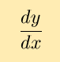
based on our knowledge of the functions f and g. Now, we know that
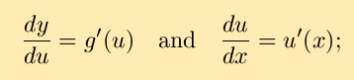
Leibniz's differential notation suggests that perhaps derivatives can be treated as fractions, leading to the speculation that
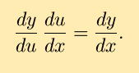
This leads to the (possible) chain rule:
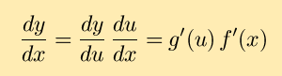

Before use the chain rule, you should remember the derivatives of some common functions.
Common Functions | Function | Derivative
Constant | c | 0
Line | x | 1
 | ax | a
Square | x² | 2x
Square Root | √x | (½)x^{-½}
Exponential | e^{x} | e^{x}
 | a^{x} | ln(a) a^{x}
Logarithms | ln(x) | 1/x
 | log_{a}(x) | 1 / (x ln(a))
Trigonometry (x is in radians) | sin(x) | cos(x)
 | cos(x) | −sin(x)
 | tan(x) | sec²(x)
Rules | Function | Derivative
Multiplication by constant | cf | cf’
Power Rule | x^{n} | nx^{n−1}
Sum Rule | f + g | f’ + g’
Difference Rule | f - g | f’ − g’
Product Rule | fg | f g’ + f’ g
Quotient Rule | f/g | (f’ g − g’ f )/g²
Reciprocal Rule | 1/f | −f’/f²

Some simple Examples:
a.f(x) = e^{2x}  f´(x) = e^{2x}·2 | Differentiating the exponential function leaves it unchanged , The derivative of 2x is 2.
b. f(x) = e^{sin x}  f´(x) = e^{sin x}·cos x |  | Differentiating the exponential function leaves it unchanged ,the derivative of sin x is cos x.

c. f(x) = ln(x² + 1).
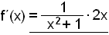
d.f(x) = x·ln x – x + 5
f´(x) = 1·lnx + x·1/x – 1 = ln x

Example
The function sin(2x) is the composite of the functions sin(u) and u=2x. Then,
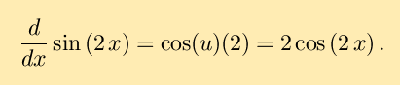
Example
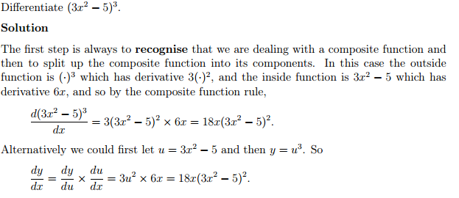
Example
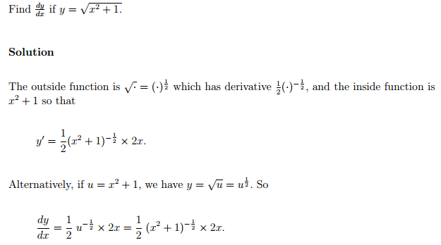

Reference
MIT Open course
http://www.rasmus.is/uk/t/F/Su64k05.htm
https://sydney.edu.au/stuserv/documents/maths_learning_centre/compositefunctionrule.pdf

