CHAPTER 8 RISK-AVERSION, CAPITAL ASSET ALLOCATION, AND MARKOWITZ PORTFOLIO-SELECTION MODEL

1.

2. The variance of a portfolio consists of two components:
a) A weighted average of the variances of the securities in the portfolio.
b) A component which measures the relationship between each pair of securities in the portfolio. This relationship is measured by the covariance.

For a two security portfolio:

3. implies risk averse
implies risk neutral
implies risk seeker

(a)

(b)

(c)

(d)

4. A fair game means that the expected returns given information set θ equal the expected returns without the information set. In other words, the returns already reflect all information.

Sometimes we define an investor’s risk preferences by looking at his preferences towards a fair gamble. A fair gamble is defined as a gamble where the cost equals the expected value.

Risk averse investors always reject a fair gamble.

Risk neutral investors are indifferent to a fair gamble.

Risk seeking investors will always accept a fair gamble.

5. a)

b)

6. An efficient portfolio is one which has the highest expected return for a given level of risk. Likewise, an inefficient portfolio is one which does not have the highest expected return for a given level of risk.

We can use the dominance principle to show that inefficient portfolios will always be dominated by other portfolios.

7. Short selling entails the selling of a security that you don’t own. In portfolio theory, the selling short of one asset is often used to provide the funds to purchase another asset.

The efficient frontier consists of all portfolios which satisfy the following two conditions.

1) Have the highest expected return for a given level of risk,

and

2) Have the lowest risk for a given expected return.

Efficient Frontier Efficient Frontier
Without Short Selling With Short Selling

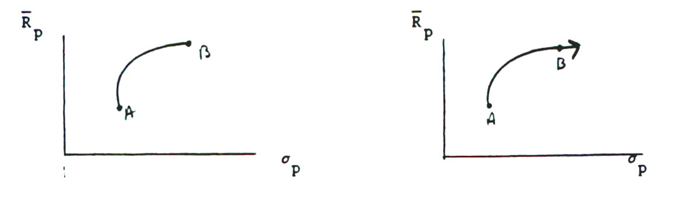

8. Margin requirements determine the amount of money an investor can borrow to purchase shares of stock.

The Dyl Model, which incorporates margin requirements into the Markowitz Model, causes the efficient frontier to shift to the northeast. [See Figure 8-10B of text.]

9. a)
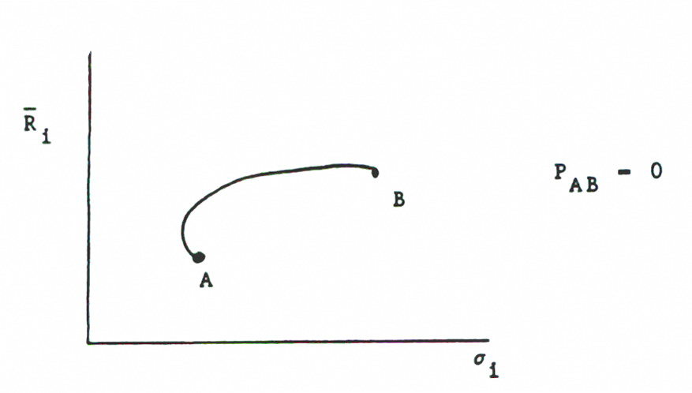
b)
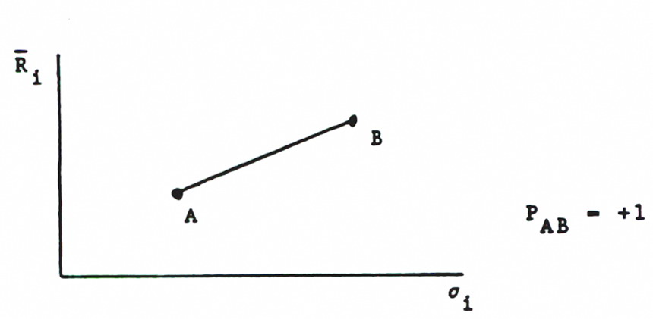
c)
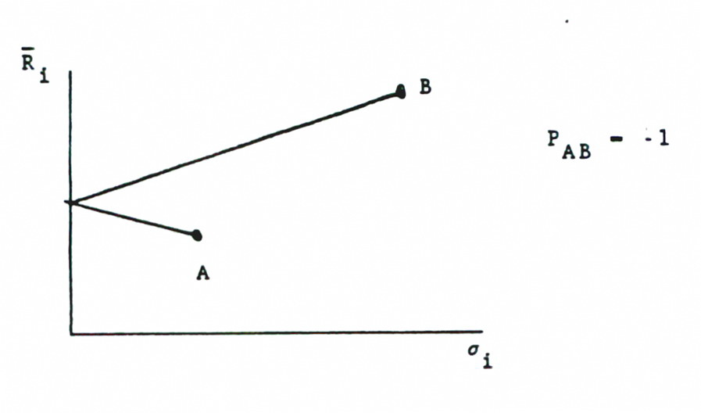
10. a) Minimum risk portfolio can be found by
and solving for W_{A}.

So, sell short 23.52% of asset A and place 123.52% in asset B to minimize the risk of the portfolio.

Var(R_{P}) = (–.2352)²(3)² + (1.2352)² (2)² + 2(–.2352)(1.2352)(3)(2)(.8) = 3.81

b) By selling short the risk free asset, you can obtain the additional funds necessary for investing an additional $5,000 in the risky portfolio.

11. If we assume that Investors can borrow and lend at the risk free rate R_{f} and if Investors have the same expectations, there will be only one best portfolio.

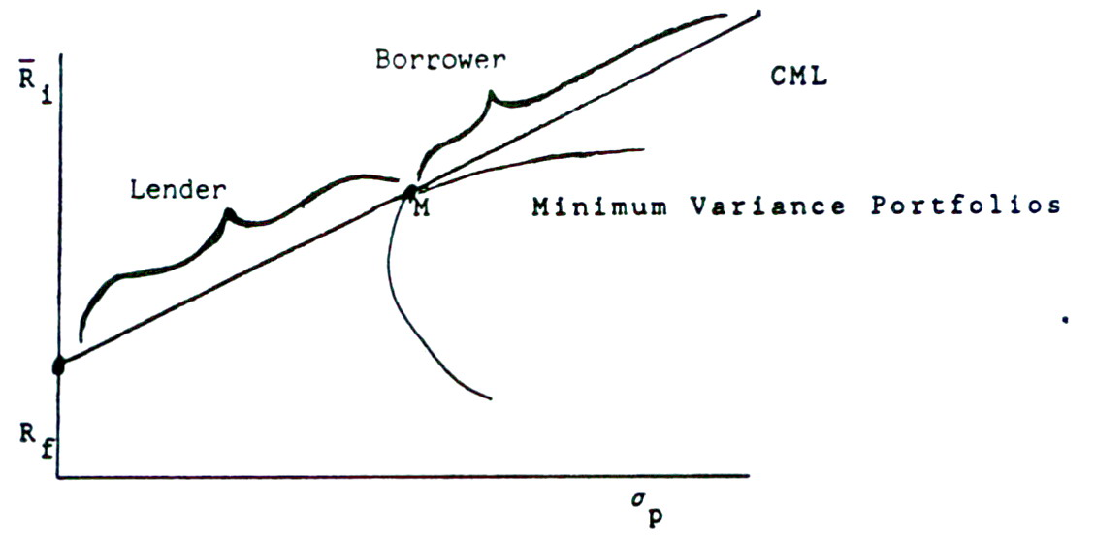

Both John Doe and Jane Roe will purchase the same portfolio, portfolio M, because the combination of the risk free asset and portfolio M dominates all other combinations. However, Jane Roe will probably place some of her money in the riskless asset and some in portfolio M, i.e. she will be a lender. John Doe, on the other hand, will most likely borrow at the risk free rate to buy more of portfolio M, i.e. he will be a borrower.

12. To determine the optimal weights for a portfolio using the Markowitz approach, the portfolio manager can either:

1) Set a target rate of return and find the portfolio which has the least risk.

or

2) Set a level of risk for the portfolio and maximize the expected return for this given level of risk.

These two problems can be solved using calculus or linear programming methods on a computer.
13. Based on Appendix 10C, we can use Microsoft Excel to calculate the optimal weights of Markowitz model.
In Markowitz Model in equation (8.13), we know
. (8.13)
Where E* =10%, the required rate of return of the portfolio. From the matrix calculation of Markowitz Model, we can get the optimal weights from multiplying and .
.
Based on Excel function, the values of average and variance are calculated by “AVERAGE” and “VARP” functions and the covariance matrix is calculated by “Covariance” in “Data Analysis.”
 | JNJ | IBM |  | BA
 | 0.0082 | 0.0050 |  | 0.0113
Variance | 0.0025 | 0.0070 |  | 0.0082
Variance Covariance Matrix
 | JNJ | IBM | BA
JNJ | 0.0025 | 0.0007 | 0.0007
IBM | 0.0007 | 0.0070 | 0.0006
BA | 0.0007 | 0.0006 | 0.0082

Therefore, we can obtain matrix A and K as follows:
Matrix A
0.0050 | 0.0014 | 0.0015 | 1.0000 | 0.0082
0.0014 | 0.0141 | 0.0013 | 1.0000 | 0.0050
0.0015 | 0.0013 | 0.0164 | 1.0000 | 0.0113
1.0000 | 1.0000 | 1.0000 | 0.0000 | 0.0000
0.0082 | 0.0050 | 0.0113 | 0.0000 | 0.0000

Then, from the matrix calculation of Markowitz Model, we can get the optimal weights from multiplying and .
.

Where matrix is
96.4952 | -47.8974 | -48.5978 | 0.5160 | 17.4282
-47.8974 | 23.7749 | 24.1225 | 1.5313 | -166.1896
-48.5978 | 24.1225 | 24.4752 | -1.0473 | 148.7614
0.5160 | 1.5313 | -1.0473 | -0.0488 | 5.5748
17.4282 | -166.1896 | 148.7614 | 5.5748 | -690.3857

The optimal weights in W matrix as follows:
W1 | 2.2588
W2 | -15.0877
W3 | 13.8289
λ1 | 0.5087
λ2 | -63.4638
If short-selling is allowed, the optimal weights for JNJ, IBM and BA are 2.2588, -15.0877, and 13.8289 respectively. If short-selling is not allowed, we can obtain the adjusted weights from equation (8.19) as follows:

14. There are four companies in the portfolio, therefore the matrix to calculate the optimal weights are shown as follows:

Where E* =12%, the required rate of return of the portfolio.

The information about the mean and variance of rate of returns for four companies are as follows:
 | JNJ | IBM |  | BA |  | CAT
 | 0.0082 | 0.0050 |  | 0.0113 |  | 0.0169
Variance | 0.0025 | 0.0070 |  | 0.0082 |  | 0.0097
Variance Covariance Matrix
 | JNJ | IBM | BA |  | CAT
JNJ | 0.0025 | 0.0007 | 0.0007 |  | 0.0011
IBM | 0.0007 | 0.0070 | 0.0006 |  | 0.0025
BA | 0.0007 | 0.0006 | 0.0082 |  | 0.0031
CAT | 0.0011 | 0.0025 | 0.0031 |  | 0.0097

Therefore, we can obtain matrix A and K as follows:
0.0050 | 0.0014 | 0.0015 | 0.0021 | 1.0000 | 0.0082
0.0014 | 0.0141 | 0.0013 | 0.0049 | 1.0000 | 0.0050
0.0015 | 0.0013 | 0.0164 | 0.0063 | 1.0000 | 0.0113
0.0021 | 0.0049 | 0.0063 | 0.0194 | 1.0000 | 0.0169
1.0000 | 1.0000 | 1.0000 | 1.0000 | 0.0000 | 0.0000
0.0082 | 0.0050 | 0.0113 | 0.0169 | 0.0000 | 0.0000

By excel function, the inverse of matrix A can be calculated as:
99.9015 | -55.8418 | -36.9166 | -7.1432 | 0.8552 | -24.9153
-55.8418 | 42.3581 | -3.2389 | 16.7226 | 0.7365 | -66.8810
-36.9166 | -3.2389 | 64.7865 | -24.6310 | 0.1239 | 2.3676
-7.1432 | 16.7226 | -24.6310 | 15.0516 | -0.7156 | 89.4287
0.8552 | 0.7365 | 0.1239 | -0.7156 | -0.0148 | 1.3243
-24.9153 | -66.8810 | 2.3676 | 89.4287 | 1.3243 | -159.0383

Then, from the matrix calculation of Markowitz Model, we can get the optimal weights from multiplying and .

The optimal weights in W matrix as follows:

W1 | -2.1346
W2 | -7.2892
W3 | 0.4080
W4 | 10.0159
λ1 | 0.1442
λ2 | -17.7603

If short-selling is allowed, the optimal weights for JNJ, IBM, BA, and CAT are -2.1346, -7.2892, 0.4080 and 10.0159 respectively. If short-selling is not allowed, we can obtain the adjusted weights from equation (8.19) as follows:

15. Use the same way and same information in question13 to calculate the optimal weights when E* =0.5% and inverse matrix of A is the same as in question13.
Then we can obtain optimal weight matrix W as follows:
W1 | 0.6031
W2 | 0.7003
W3 | -0.3035
λ1 | -0.0209
λ2 | 2.1228
If short-selling is allowed, the optimal weights for JNJ, IBM and BA are 0.6031, 0.7003, and -0.3035 respectively.

16. Use the same way and same information in question14 to calculate the optimal weights when E* =1% and inverse matrix of A is the same as in question14.

Then we can obtain optimal weight matrix W as follows:
W1 | 0.6061
W2 | 0.0677
W3 | 0.1476
W4 | 0.1787
λ1 | -0.0015
λ2 | -0.2661
Whether short-selling is allowed or not, the optimal weights for JNJ, IBM, BA, and CAT are 0.6061, 0.0677, 0.1476 and 0.1787 respectively.

